DATABASE MANAGEMENT

SYSTEM LAB

***LAB***

***ETCS-256***

**Faculty Name: - MS. Neelam Sharma Student Name: ARIHANT JAIN**

**Roll No.: 08914802719**

**Semester: 4th Semester**



Maharaja Agrasen Institute of Technology, PSP Area, Sector – 22, Rohini,NewDelhi – 110085

DATABASE MANAGEMENT

SYSTEM LAB

(ETCS -256)

Lab Assessment Sheet

Student Enrollment No: Student Name:

|  |  |  |  |  |  |  |  |  |
| --- | --- | --- | --- | --- | --- | --- | --- | --- |
| S.No | Experiment | Marks | | | | | Total  marks | Signature with date |
|  | R1 | R2 | R3 | R4 | R5 |
| 1 | To study the entity relationship model of DBMS using a diagrammatic representation |  |  |  |  |  |  |  |
| 2 | To study basic SQL Commands.(DDL AND DML). |  |  |  |  |  |  |  |
| 3 | To implement different SQL key constraints and clauses on a given database. |  |  |  |  |  |  |  |
| 4 | Implementation of Arithmetic and String functions on a given database. |  |  |  |  |  |  |  |
| 5 | Implementation of Operators and Views on a given database |  |  |  |  |  |  |  |
| 6 | Implementation of Joins and Index on a given Database. |  |  |  |  |  |  |  |
| 7 | To study the PL/SQL Database Management language |  |  |  |  |  |  |  |
| 8 | To study the different types of cursors and its implementation |  |  |  |  |  |  |  |
| 9 | To study the different types of triggers and its implementation |  |  |  |  |  |  |  |
| 10 | Create a program in Pl-Sql. |  |  |  |  |  |  |  |

Overall Comments:

Faculty Name: MS. Neelam Sharma

Signature

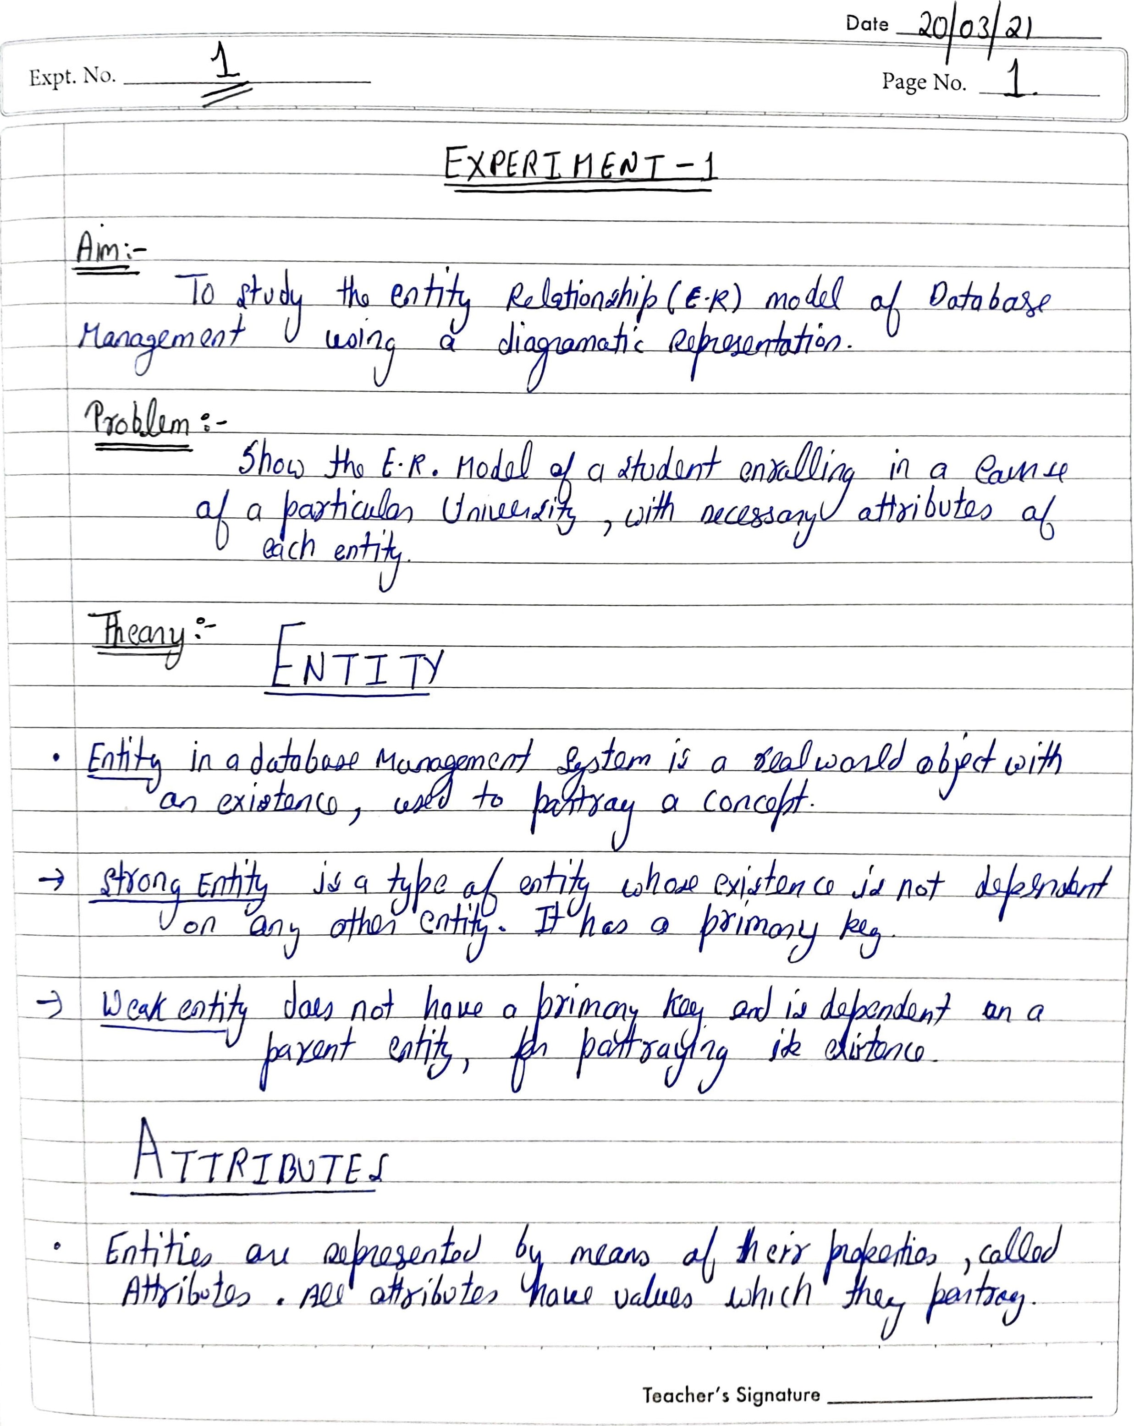

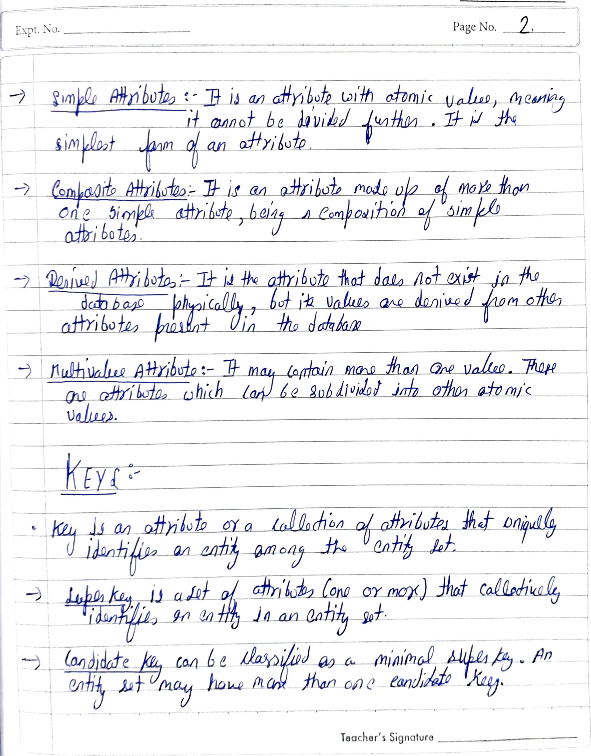

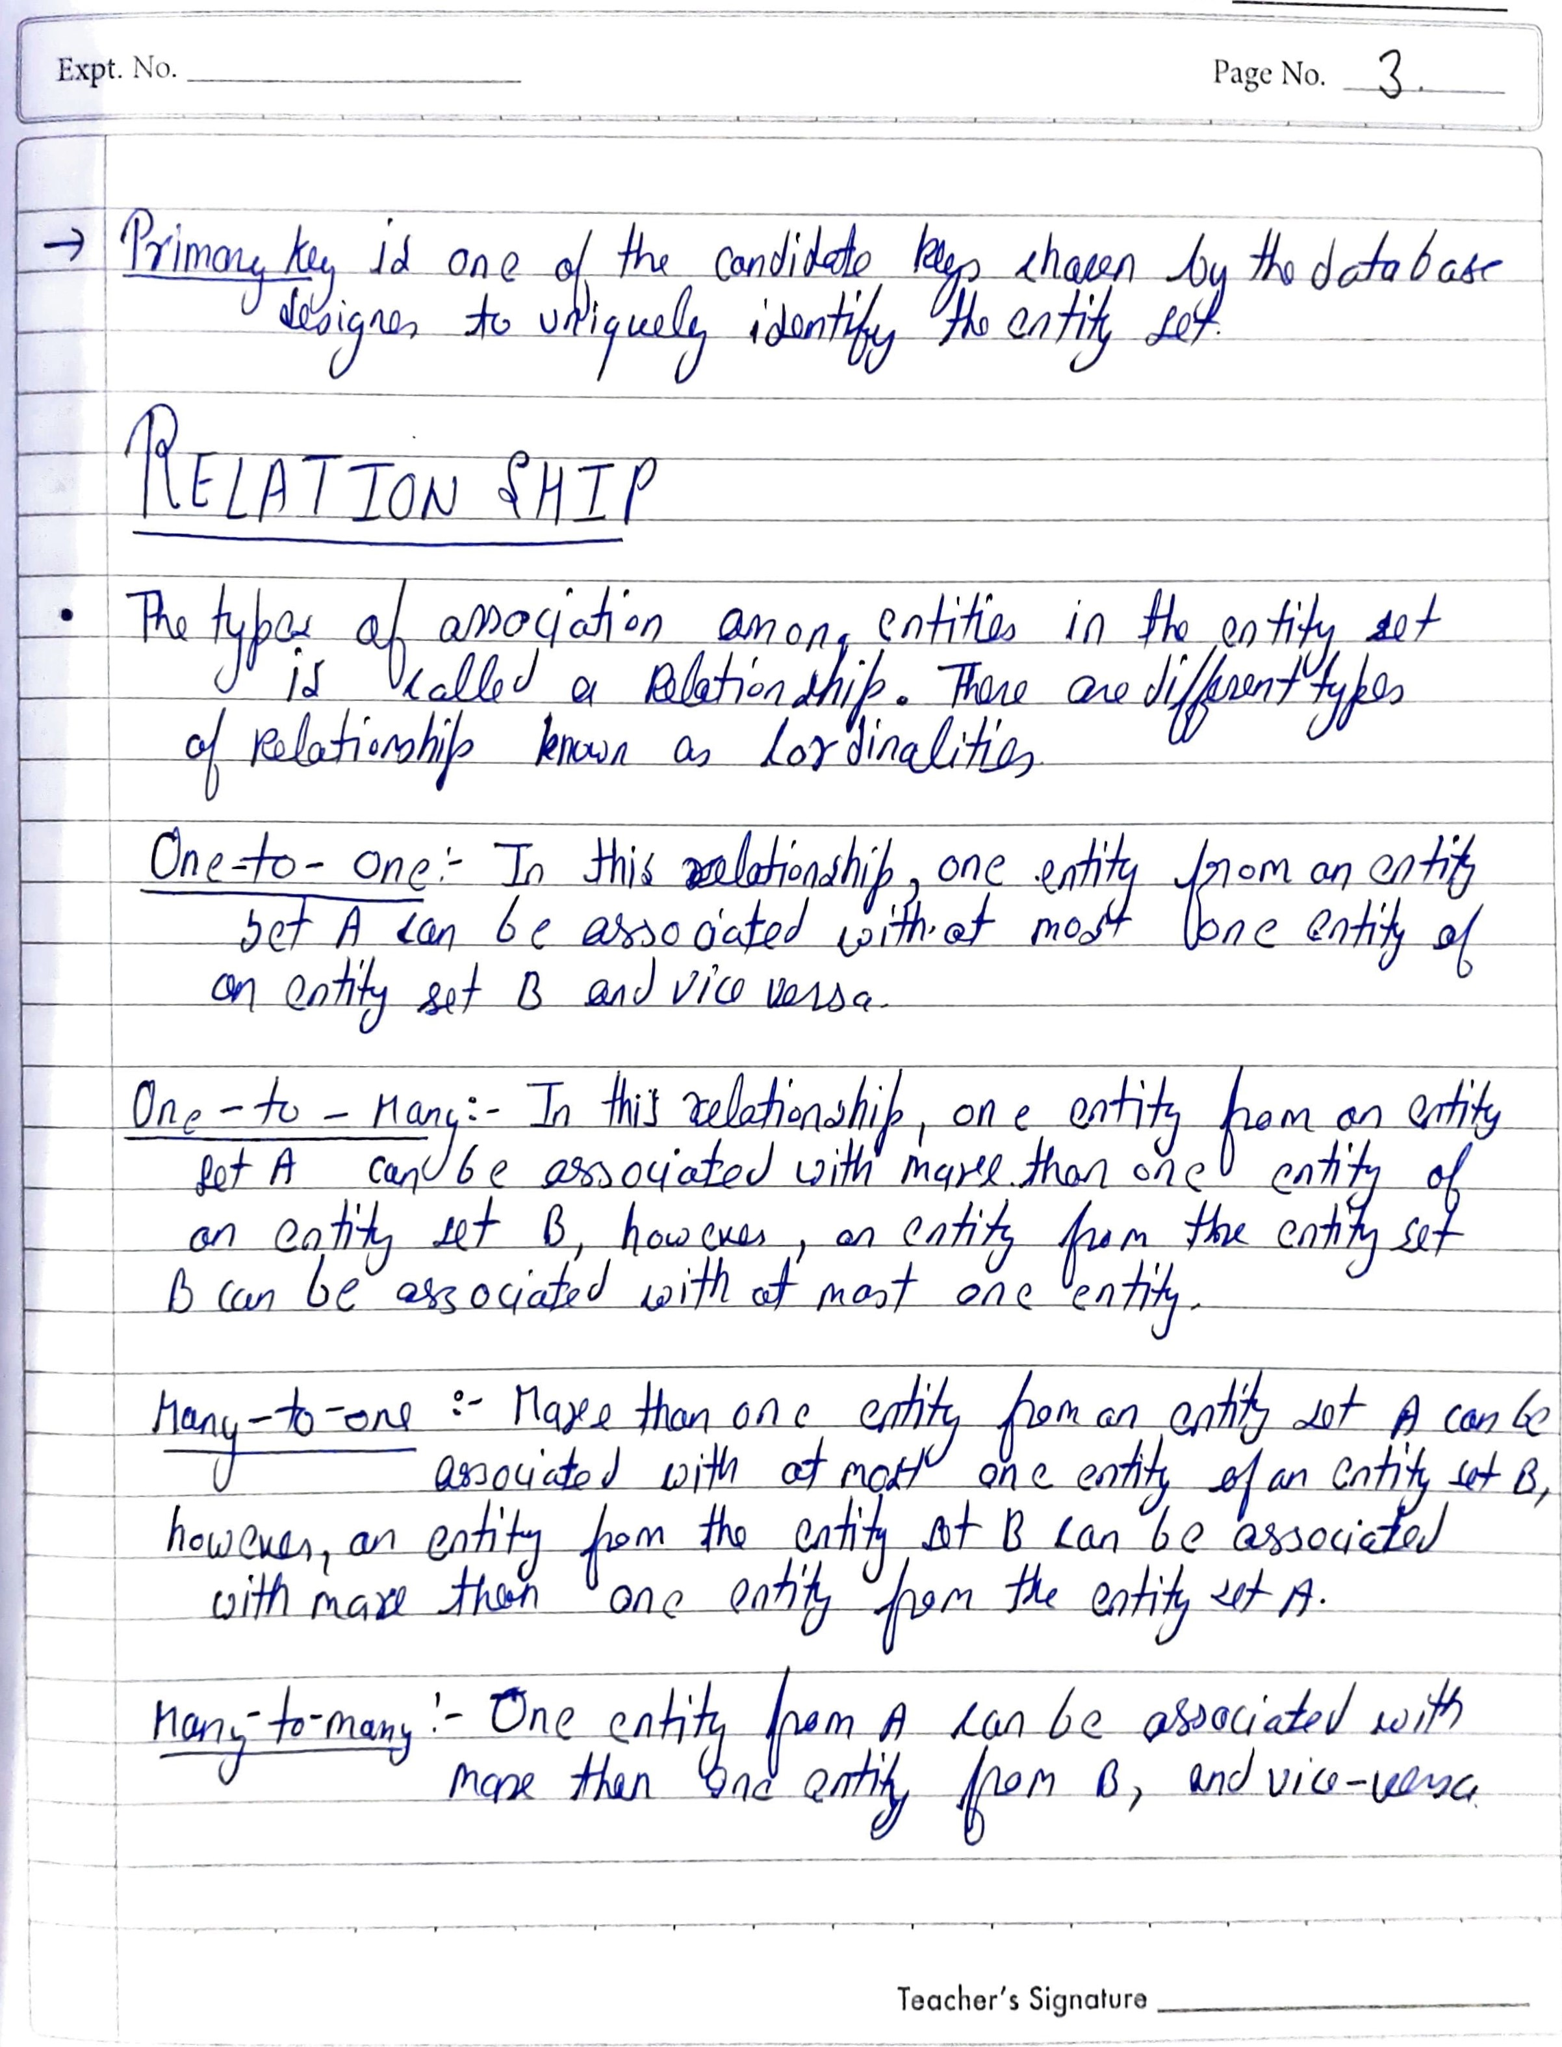

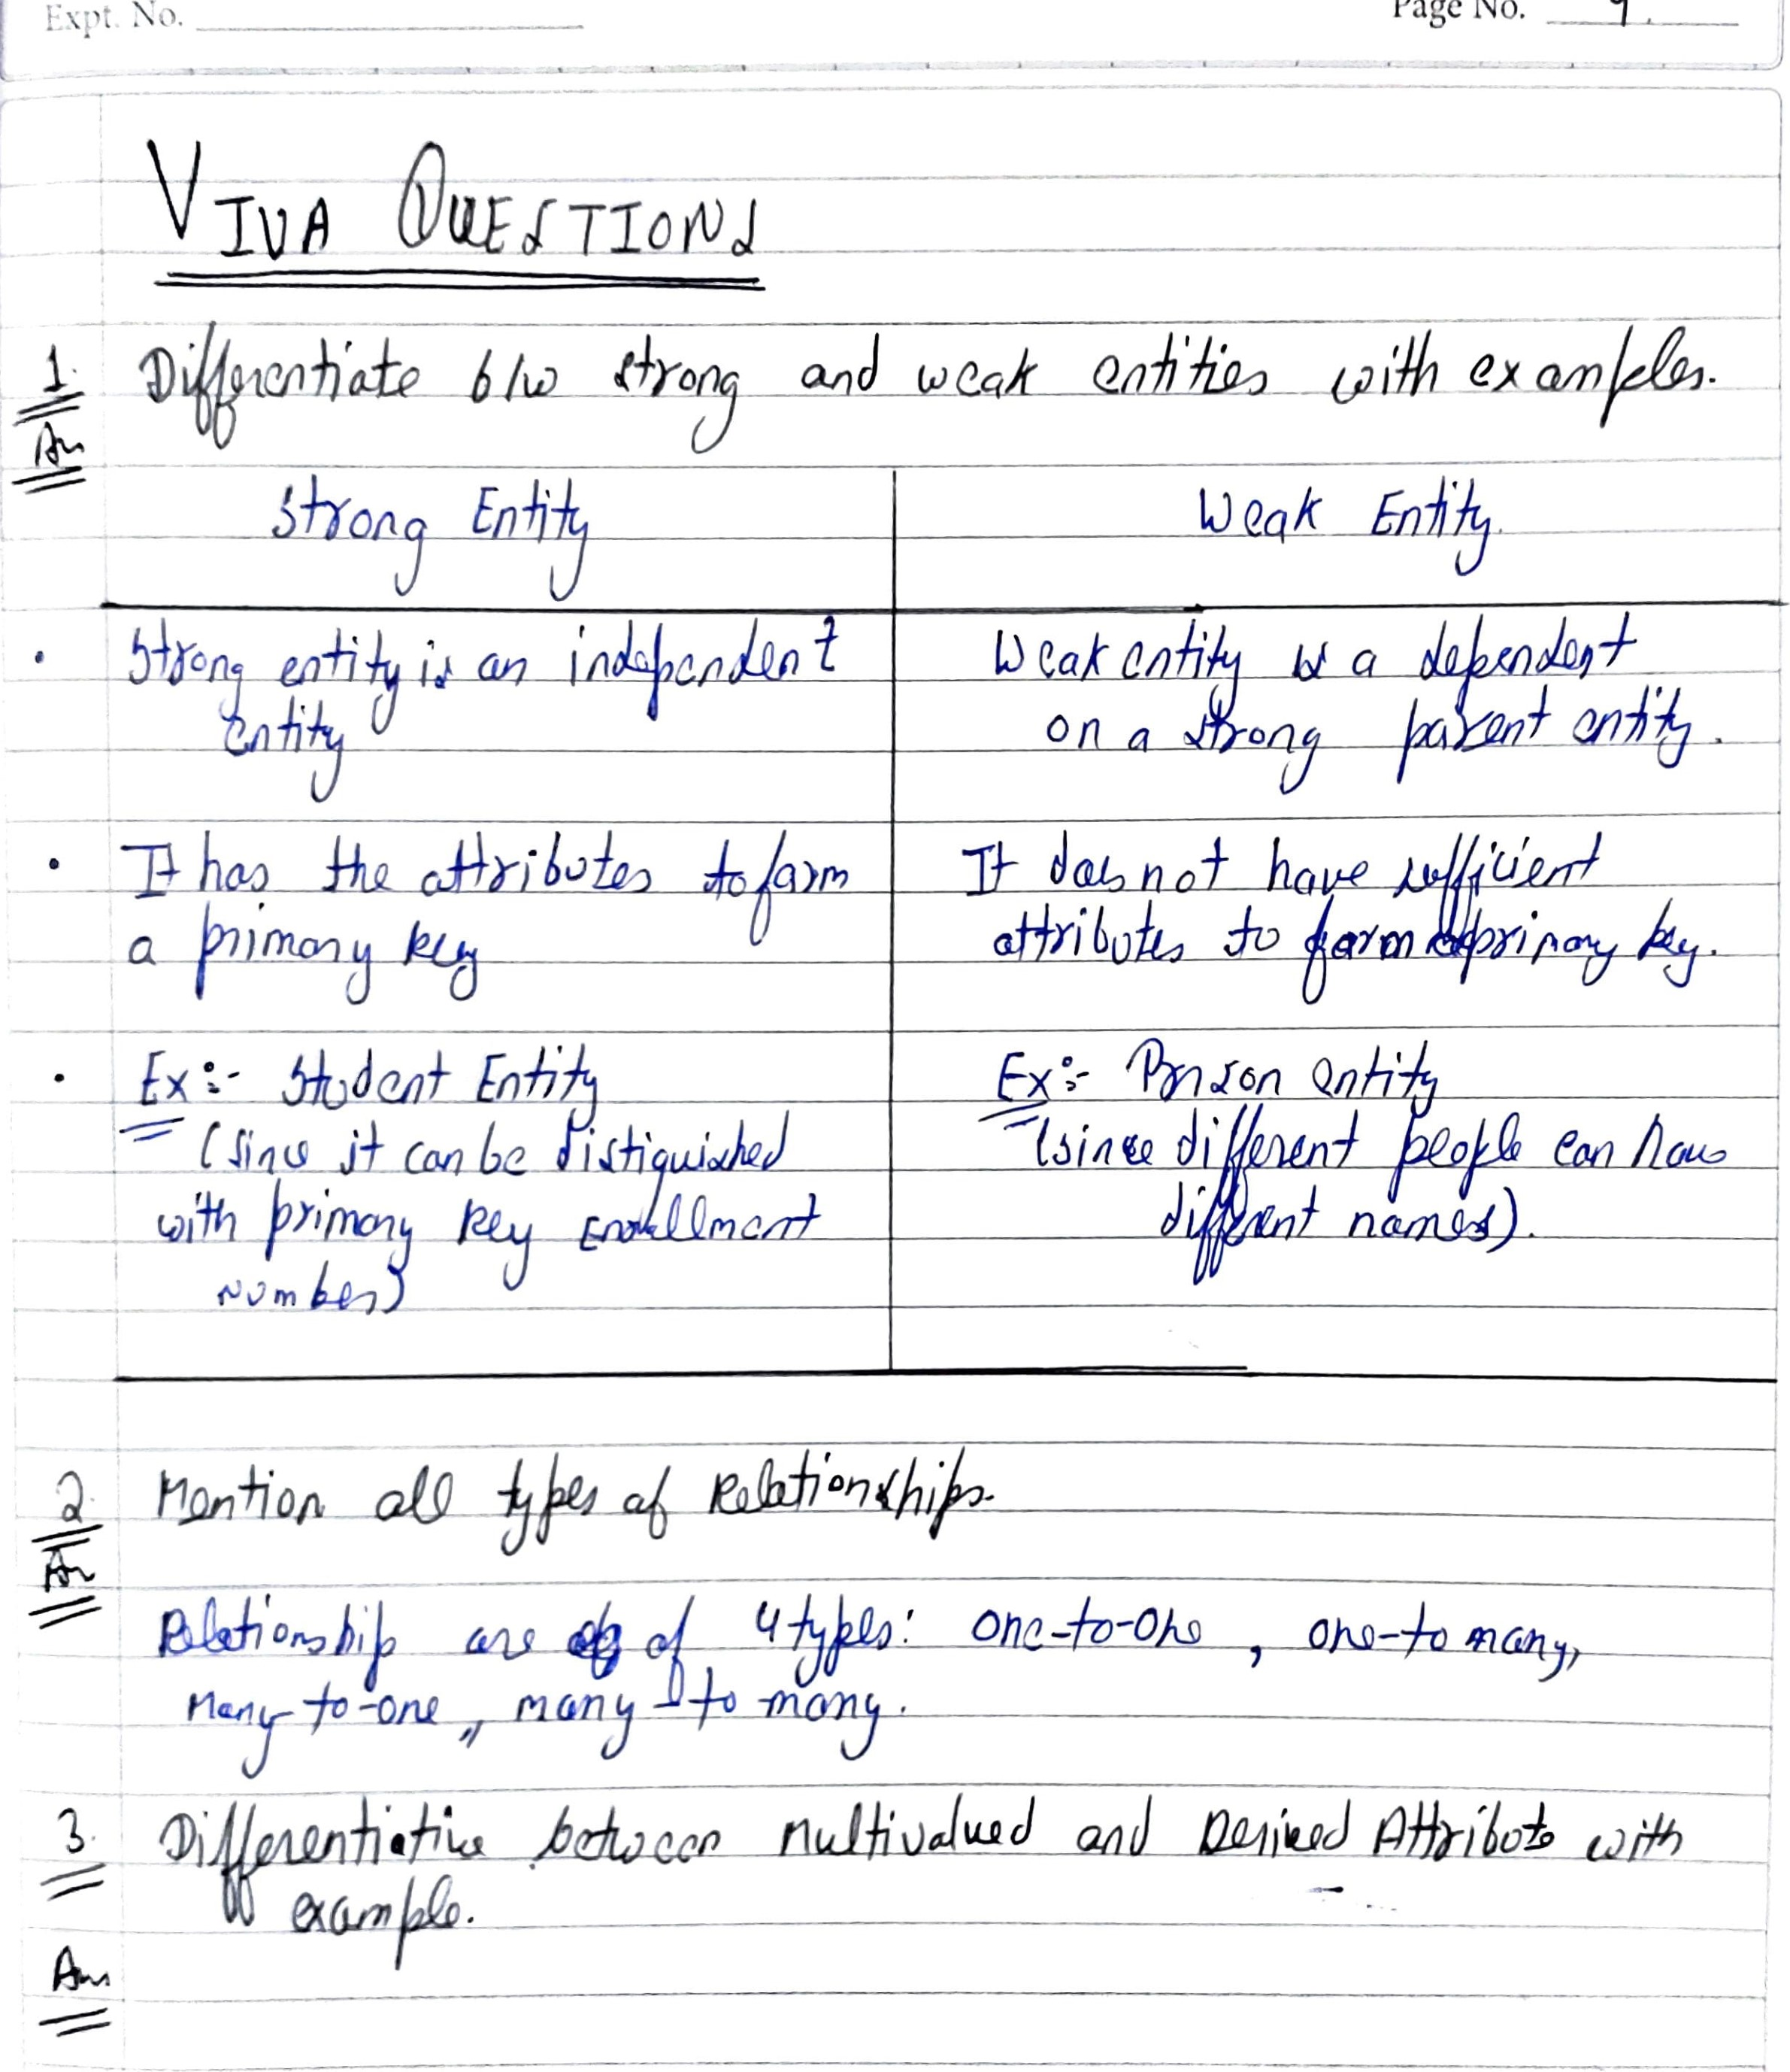

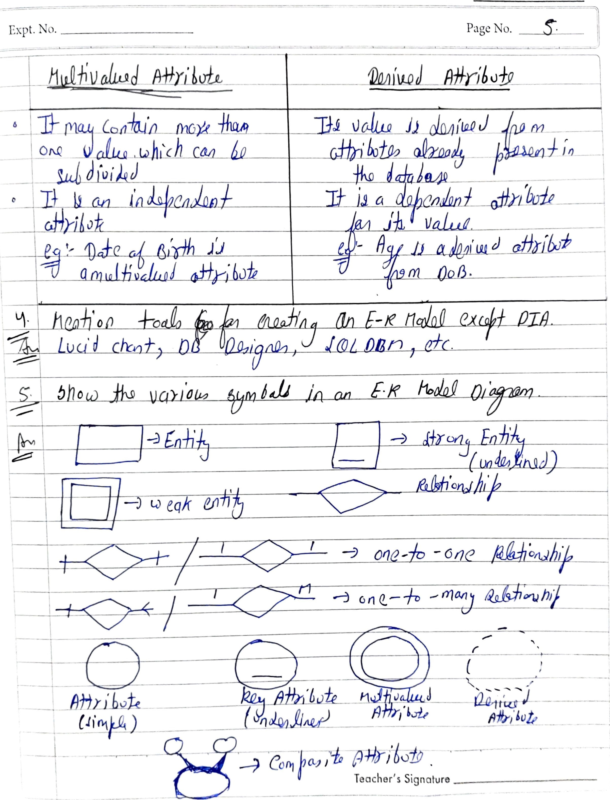

日に 印にViewいド修0bしSelect 10山InputMethOds Help

# 。「! 0日

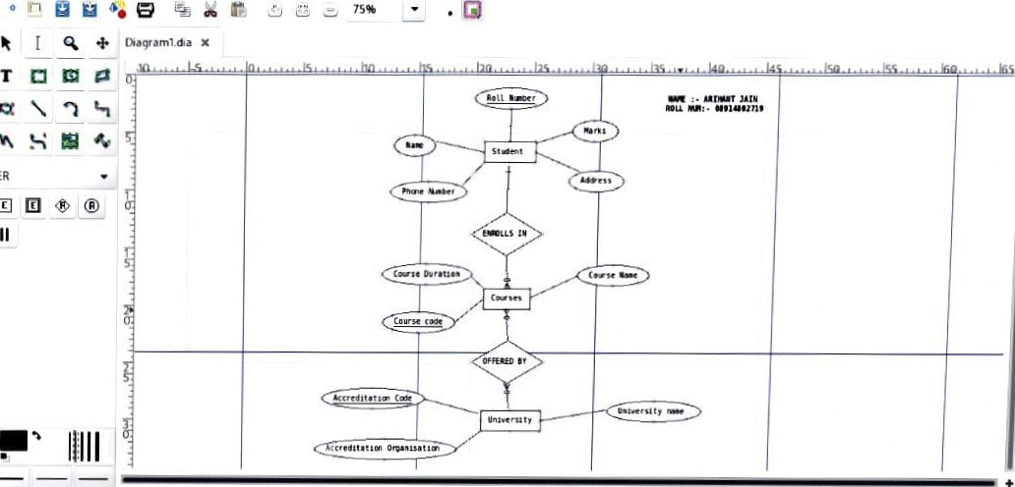

ER

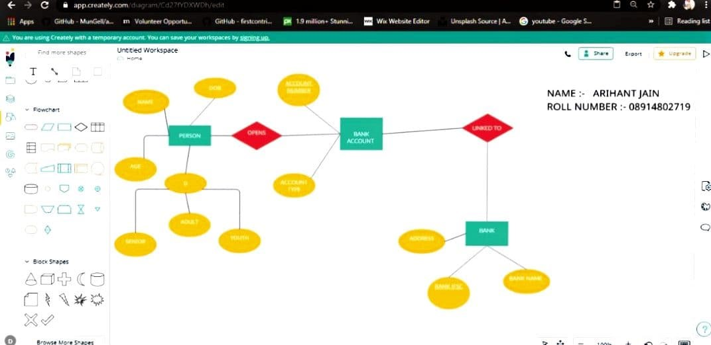

0

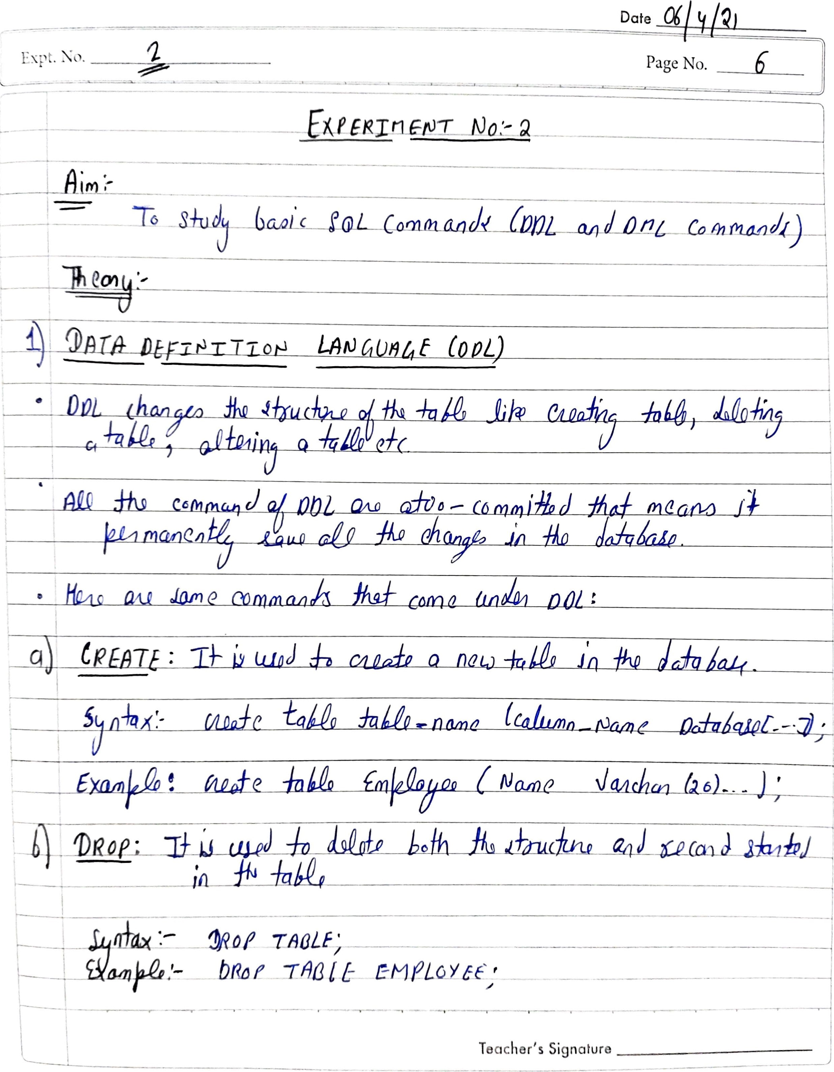

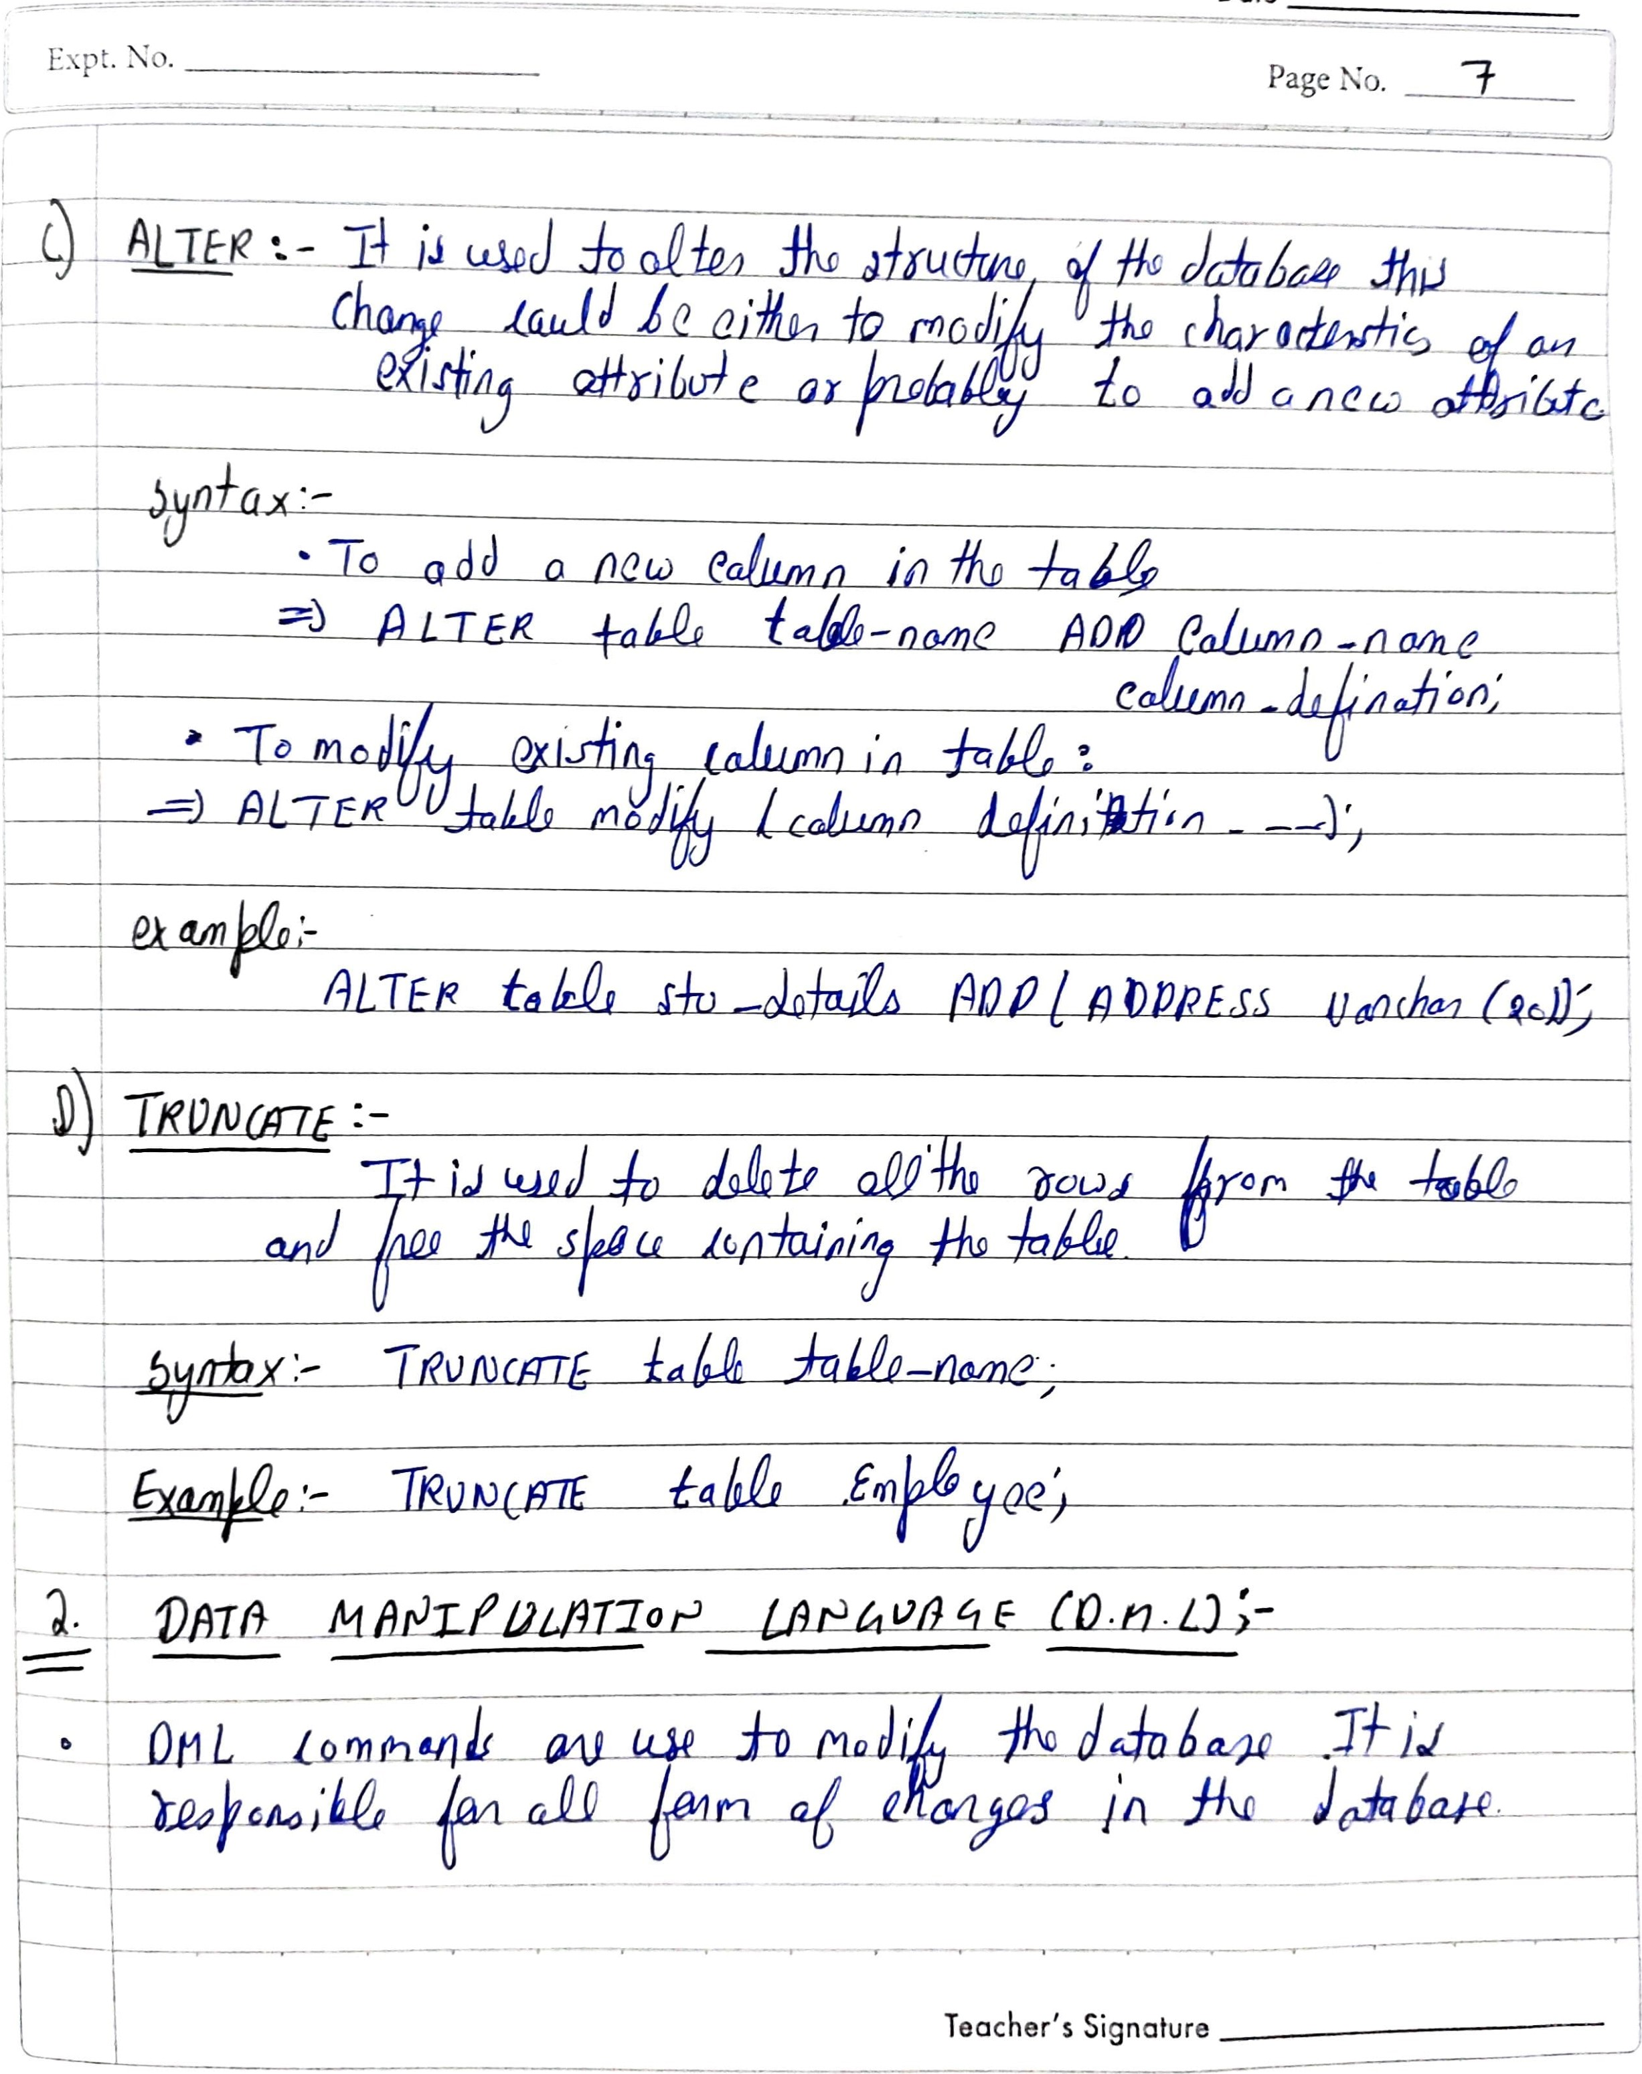

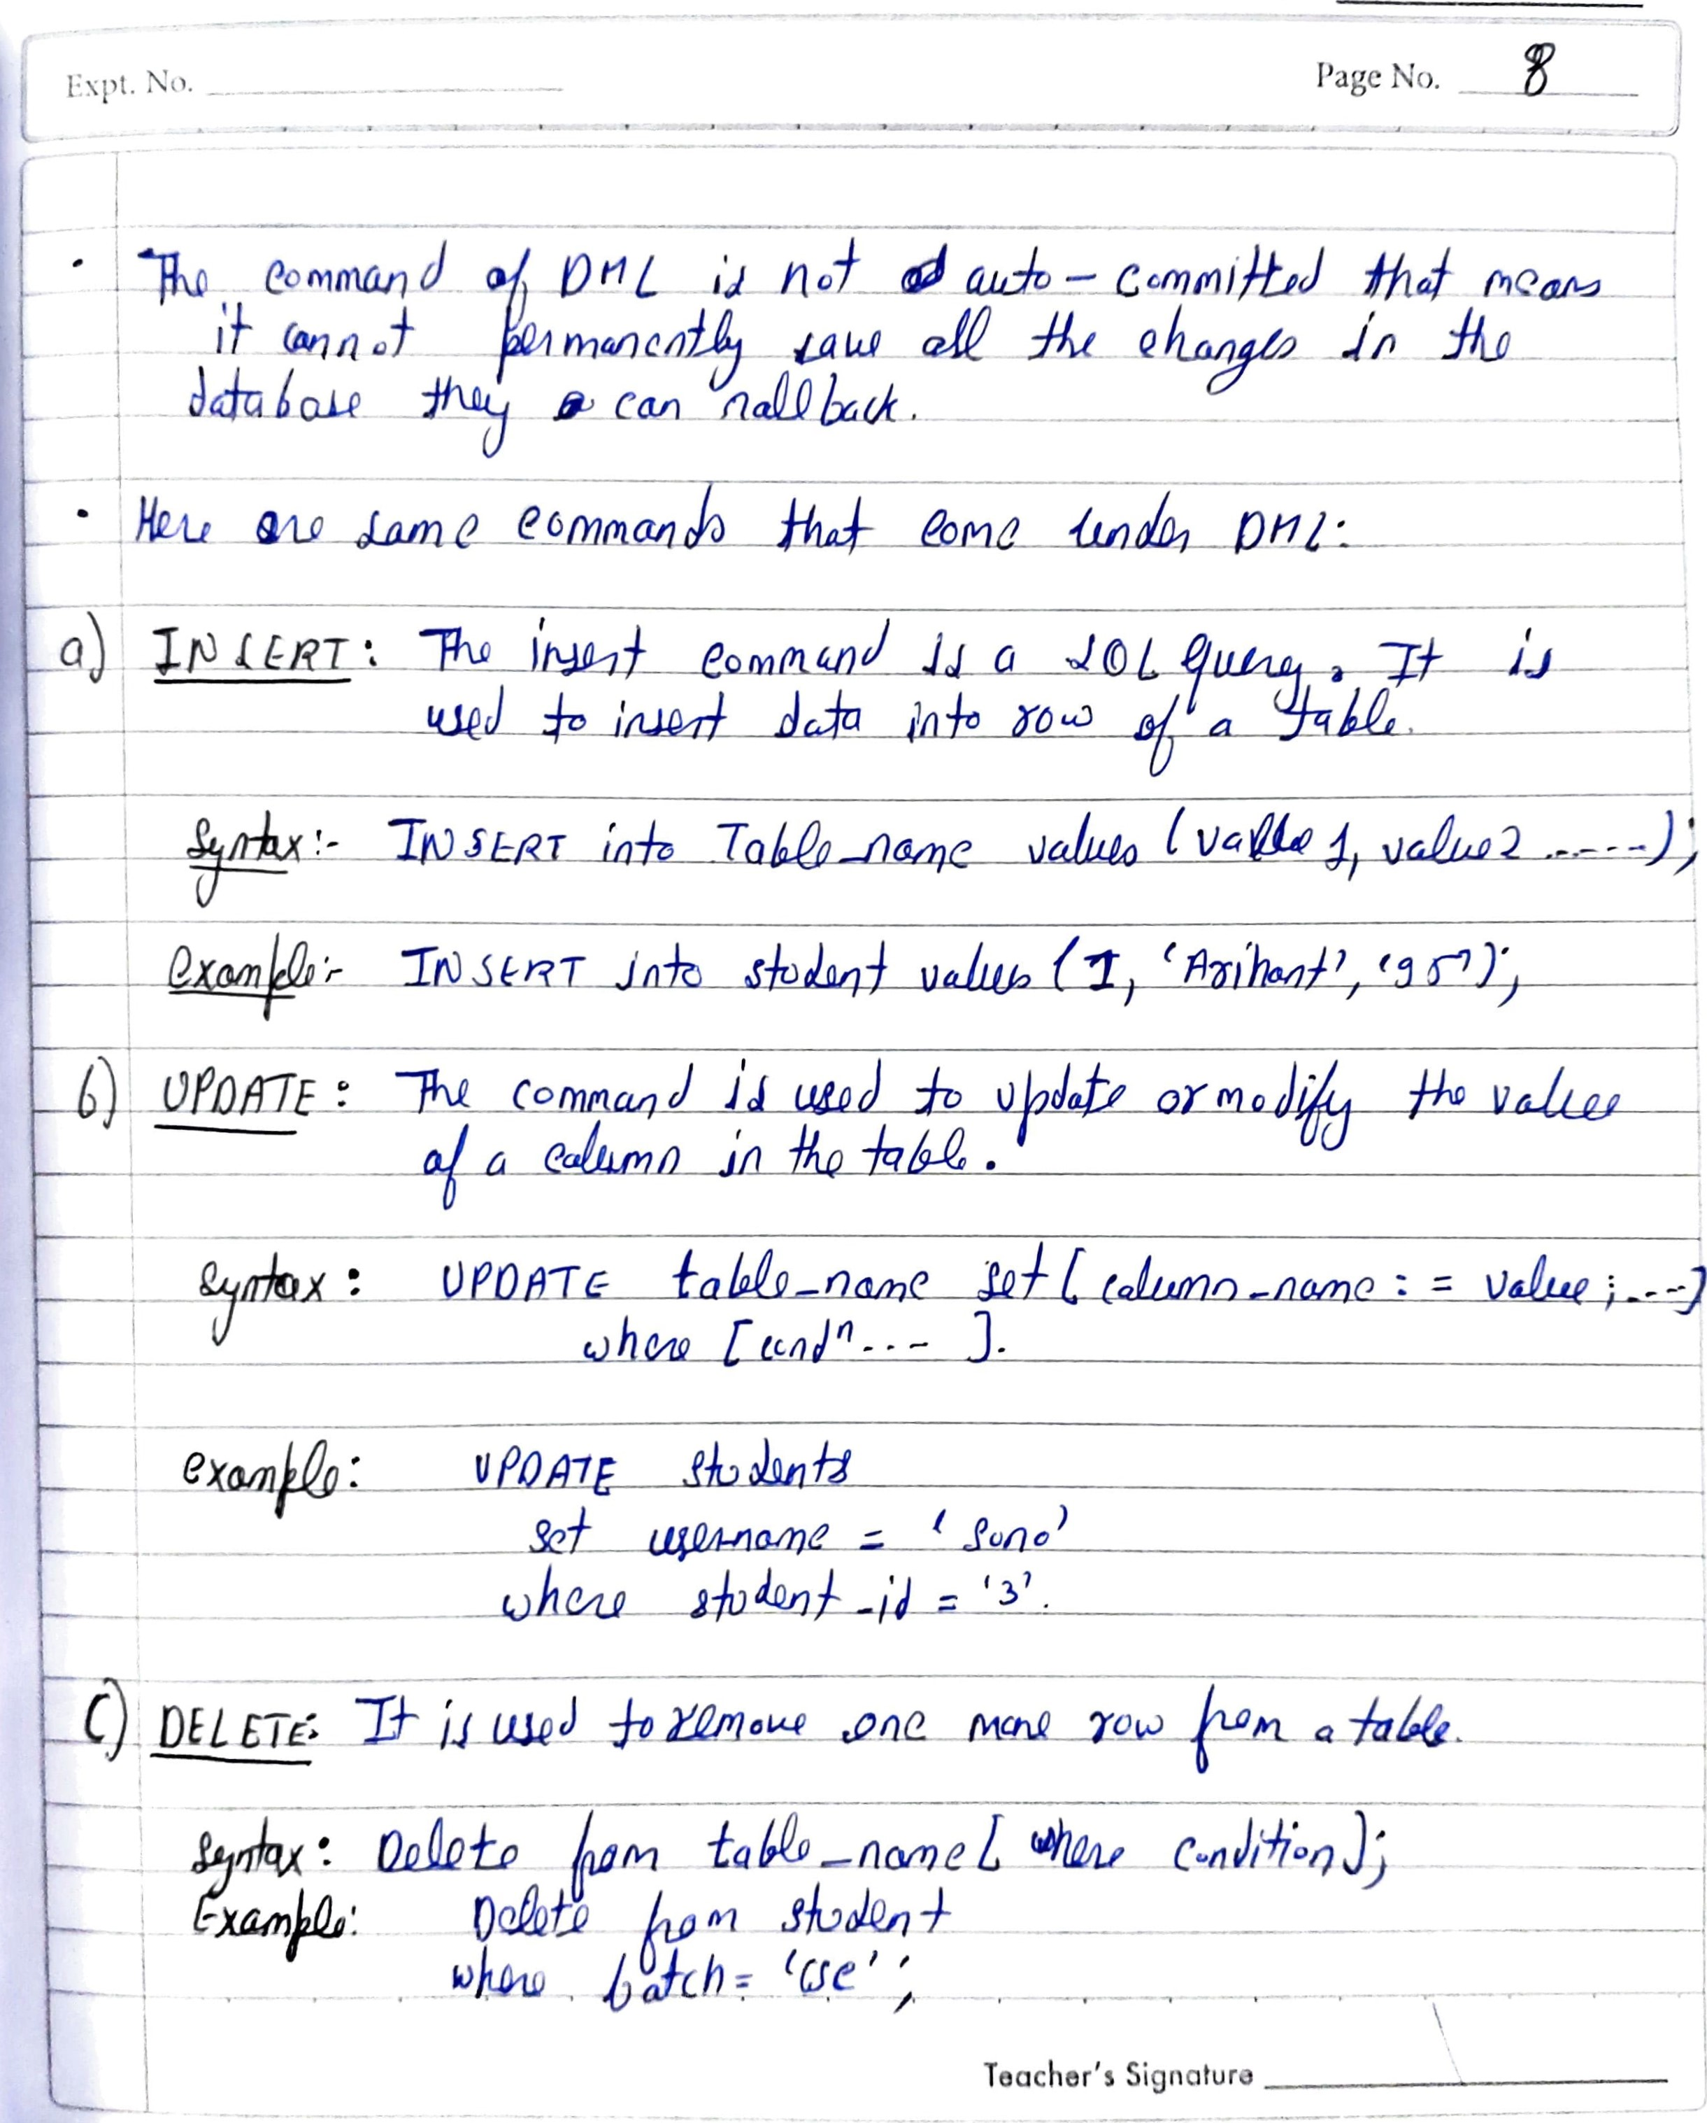



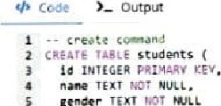

gender

7

8

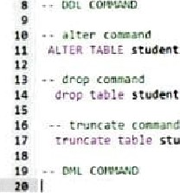

Students;

students;

TABLE students ADO phone Int(S);

Frtet

va:uøs, students'Ryan' ,

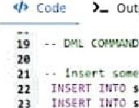

Output

23

24

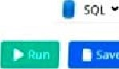 Students• 'ganna• •s • .584) ;

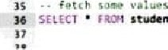

stu&nts;

- update camnant

26

27 update students

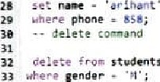

Students

34

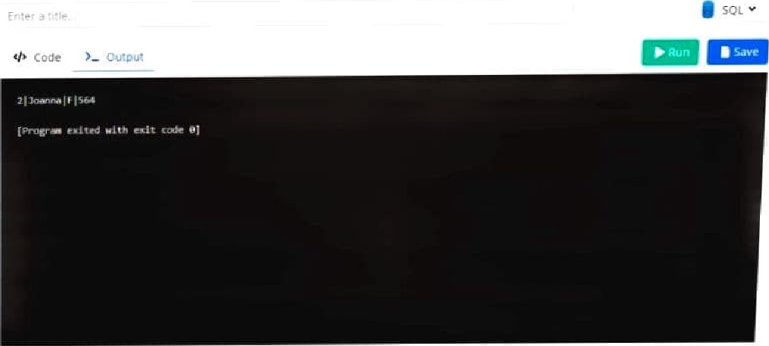

**EXPERIMENT – 3**

AIM : To implement different SQL key constraints and clauses on a given database.

**THEORY :**

**SQL KEY Constraints :-**

Constraints can be specified when the table is created with CREATE TABLE statement after the table is created with ALTER TABLE statement**.**

**Syntax:-**

CREATE TABLE table-name (

Column1 datatype constraint,

Column2 datatype constraint,

…..

);

**NOT NULL:-** Itenforces column to not accept null values. This ensures that a field always contains a to value which means that no new record can be inserted without adding this field.

Example : CREATE TABLE person(

ID int NOT NULL,

lastname varchar(225) NOT NULL,

firstname varchar(225) NOT NULL

);

**UNIQUE :** It ensures that all values in a column are different . Both UNIQUE & PRIMARY KEY constraints provide a guarantee for uniqueness of a column.

**Examples:**

CREATE TABLE persons(

ID int NOT NULL,

Name varchar(225),

UNIQUE (ID)

);

**PRIMARY KEY :** It uniquely identifies each record in a table. A primary key must contain unique values and cannot contain null values. A table can have only one primary key, which can consist of multiple columns as well

**Example :** CREATE TABLE persons (

ID int NOT NULL,

Lname varchar ( 255 ),

Fname varchar (255),

Age int,

UNIQUE (ID),

PRIMARY KEY (ID)

);

**FOREIGN KEY:** It is used to prevent actions that would destroy links between tables . A foreign key is a field in one table ,that refers to the primary key in another table. The table with foreign key is known as child table & the table with primary key is called referenced table .

**Example :**

CREATE TABLE orders(

OrdID int NOT NULL,

OrdNo. int NOT NULL,

PersonID int,

PRIMARY KEY (ordID),

FOREIGN KEY(PersonID) REFERENCES ,

Persons(PersonID)

);

**CHECK :** It is used to filter & limit the value range that can be placed in a column. If we define a CHECK constraint on a column, it will allow only certain types of values in the column.

**Example :** CREATE TABLE persons(

ID int NOT NULL,

Age int,

CHECK(Age > = 18));

**DEFAULT** :

It is used to set a default value for a column. The default value will be added to all new records, if no other is specified .

**Example :**

CREATE TABLE Orders (

ID int,

ODNO int ,

ODDATE date DEFAULT GETDATE());

**SQL CLAUSES**

**The following are the various SQL Clauses :**

**WHERE:**

It is used to filter records. It extraxts only those records that fulfill a specified condition.

**SYNTAX :**

SELECT column1, column2 ...

FROM tablename

WHERE condition;

**Example:**

SELECT *

FROM Customers

WHERE country= " Mexico " ;

**GROUP BY :**

**It is used to arrange identical data into groups. It is used with an SQL SELECT statements.It follows the WHERE clause & precedes the ORDER BY clause.**

**Syntax :**

**SELECT column FROM tablename**

**WHERE condition**

**GROUP BY column;**

**Example:**

SELECT company,Count ( * )

FROM Product

GROUP BY company ;

**HAVING :**

It is used to specify a search condition for a group or an aggregate.

**Syntax:**

SELECT column1, column2

FROM tablename

WHERE condition

GROUP BY column1, column 2

HAVING condition;

**Example:**

SELECT company count(*)

FROM Product

GROUP BY Company

HAVING count(*)>=2 ;

**ORDER BY:**

It sorts the result set in an ascending or descending order, as specified by a keyword. Sorting of records is done ascending by default .

**Syntax :**

SELECT column1,column 2

FROM tablename

WHERE condition

ORDER BY column1 ,col2,…. ASC /DESC ;

**Example:**

SELECT *

FROM Customer

ORDER BY Name ;

**OUTPUT :**

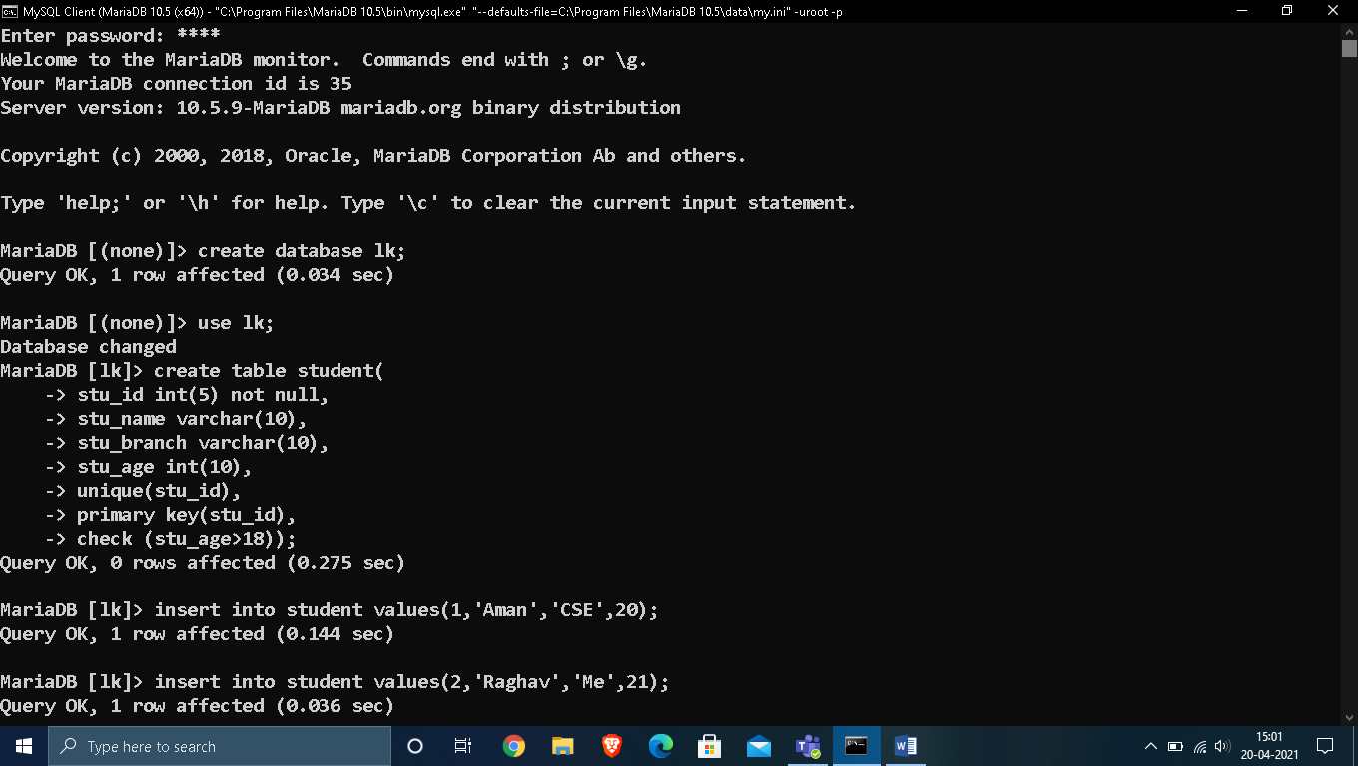

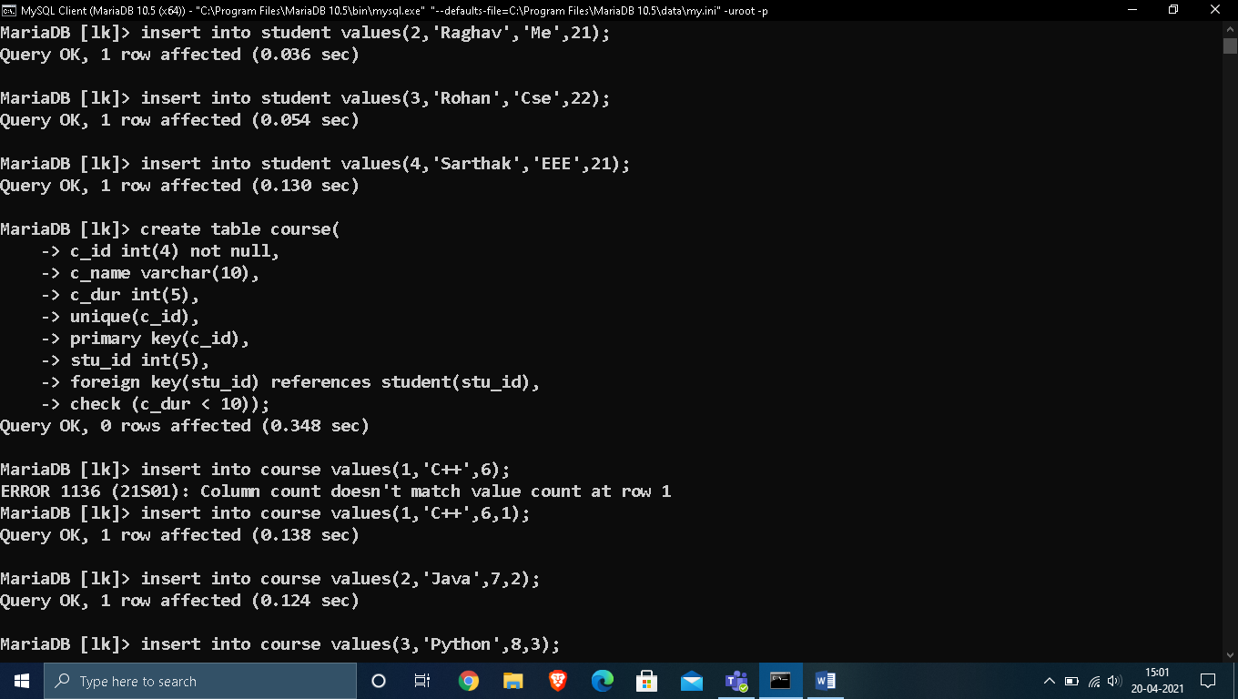

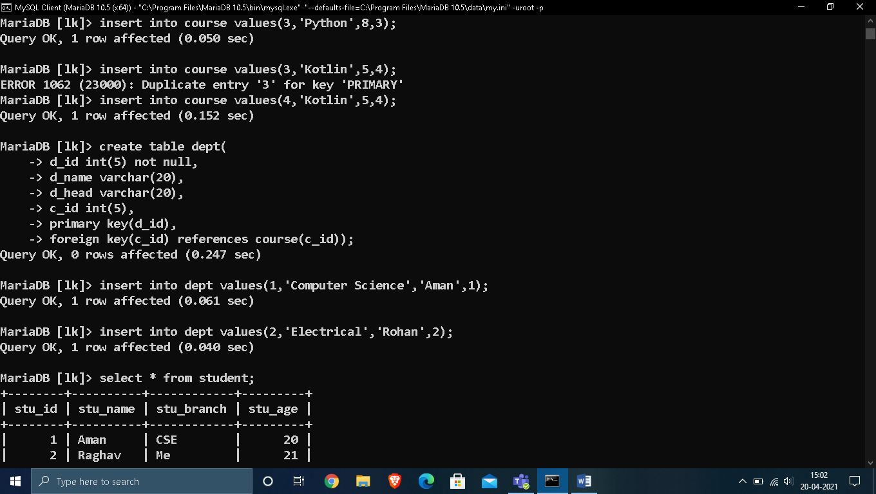

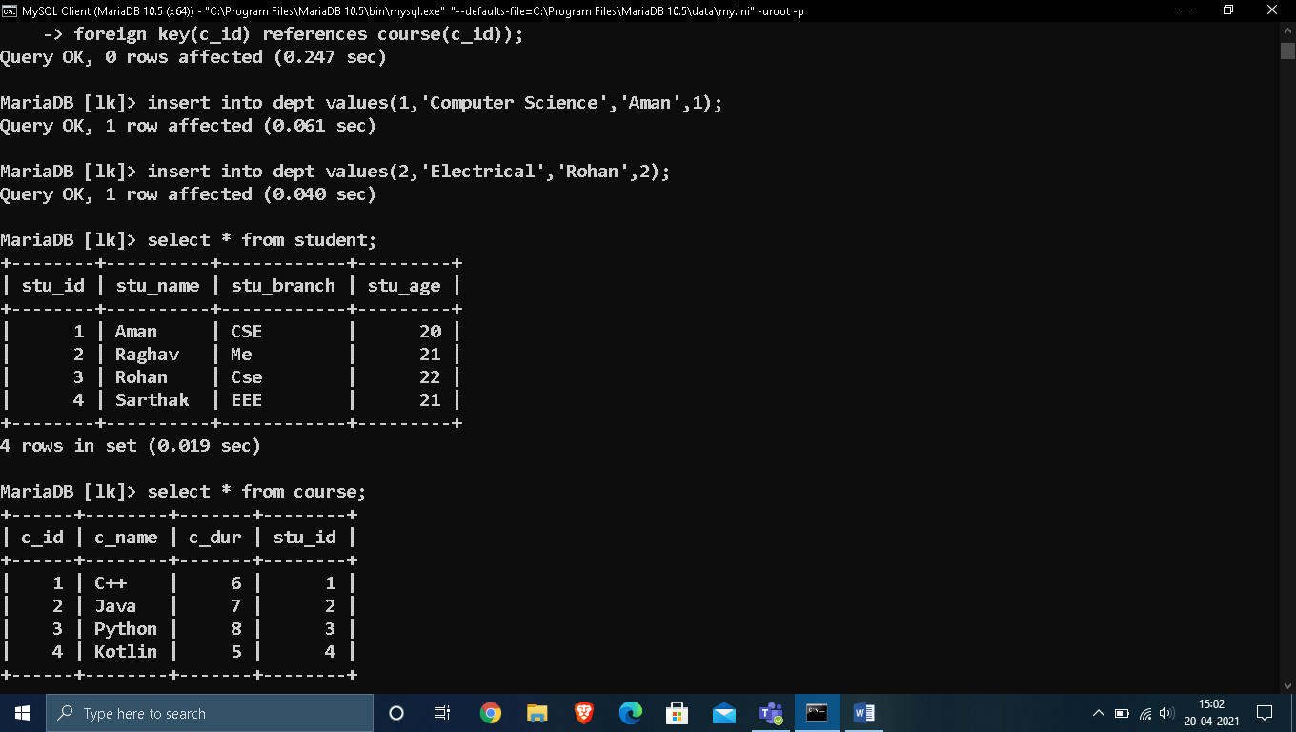

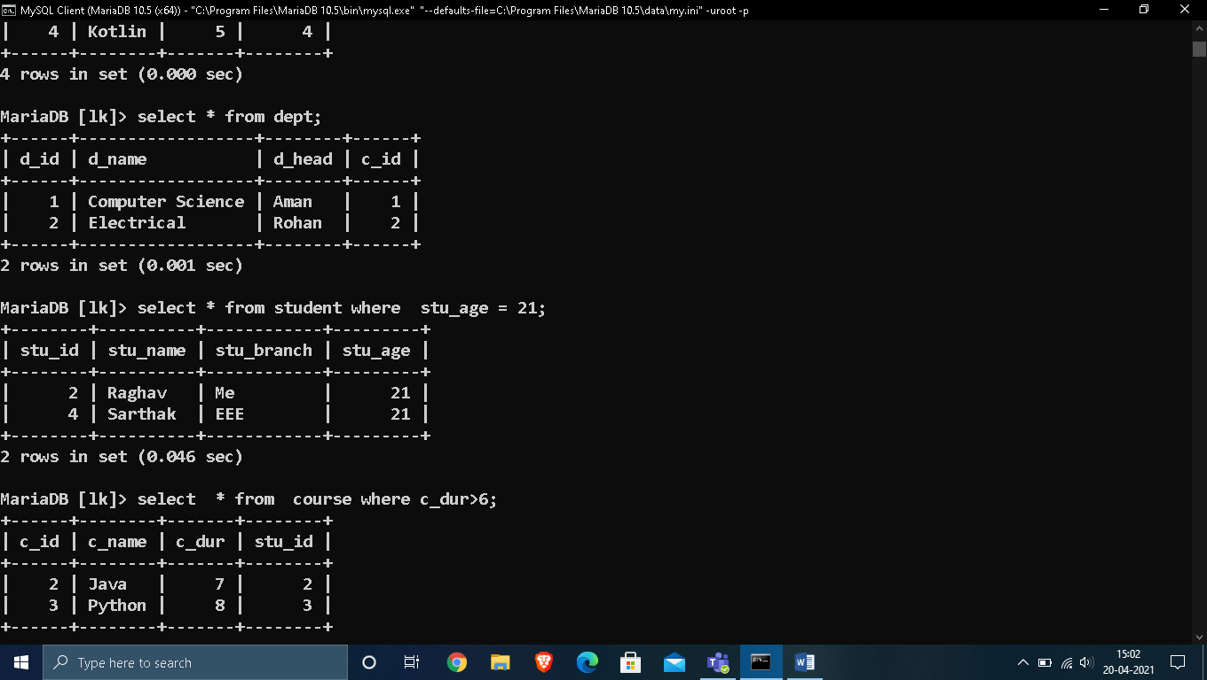

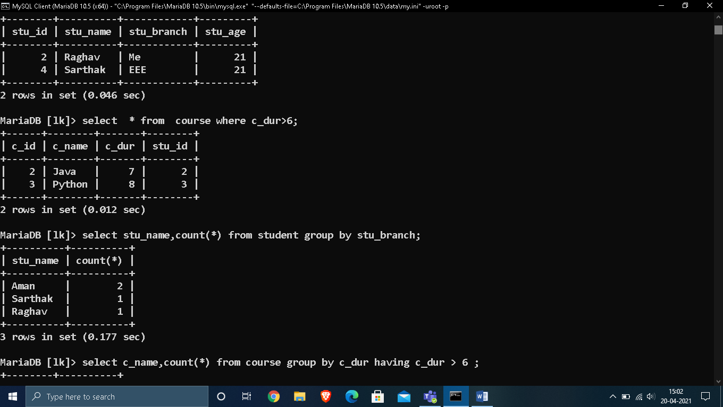

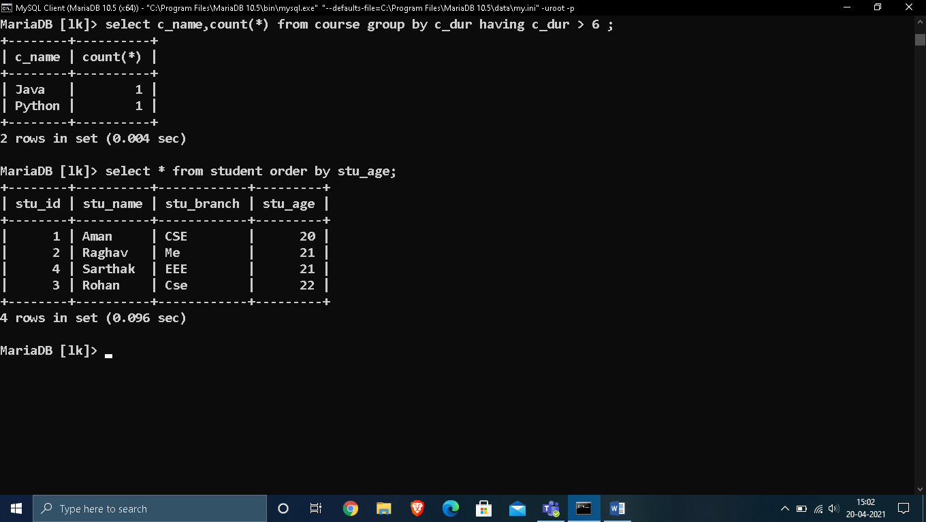

**EXPERIMENT – 4**

AIM : Implementation of Arithmetic and String functions on a given database.

**THEORY :**

**1. POWER ():**

The POWER() function returns the value of a number raised to the power of another number.

SYNTAX:-

POWER(a, b)

**2. ROUND() :**

The ROUND() function rounds a number to a specified number of decimal places.

SYNTAX:

ROUND(number, decimals, operation)

**3. SQRT () :**

The SQRT() function returns the square root of a number.

SYNTAX:

SQRT(number)

**4. COS() :**

The COS() function returns the cosine of a number.

Syntax

COS(*number*)

**5. SIN() :**

The SIN() function returns the sine of a number.

Syntax

SIN(*number*)

**6. TAN() :**

The TAN() function returns the tangent of a number.

Syntax

TAN(*number*)

**7. ABS() :**

The ABS() function returns the absolute value of a number.

Syntax

ABS(*number*)

**8. MOD() :**

SQL MOD() function is used to get the remainder from a division. The SQL DISTINCT command along with the SQL MOD() function is used to retrieve only unique records depending on the specified column or expression.

**Syntax:**

**Mod(dividend , divider);**

**9. MAX () :**

The MAX() function returns the maximum value in a set of values.

Syntax

MAX(*expression*)

**10. MIN() :**

The MIN() function returns the minimum value in a set of values.

## Syntax

MIN(*expression*)

**11. AVG () :**

The AVG() function returns the average value of an expression.

## Syntax

AVG(*expression*)

**12. CEILING () :**

The CEILING() function returns the smallest integer value that is larger than or equal to a number.

Syntax

CEILING(*number*)

**13. FLOOR () :**

The FLOOR() function returns the largest integer value that is smaller than or equal to a number.

## Syntax

FLOOR(*number*)

**OUTPUT :**

**1. POWER, ROUND, SQRT, COS FUNCTIONS :**

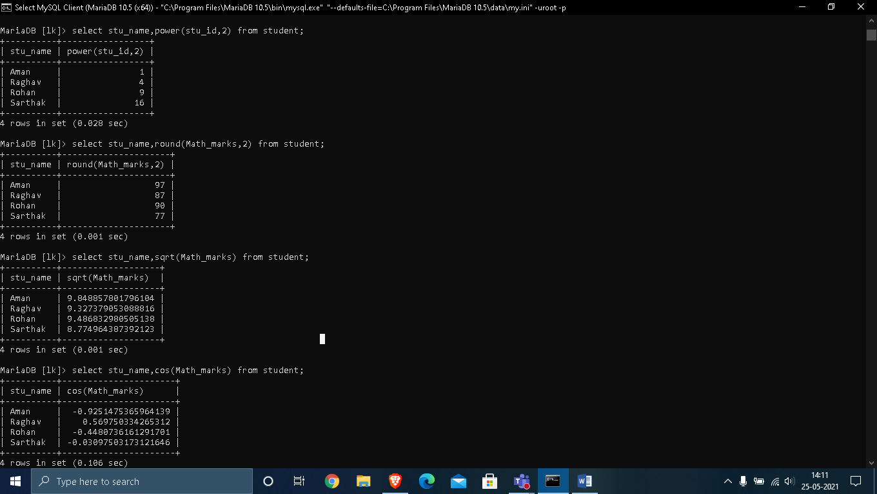

**2. SIN() ,TAN() :**

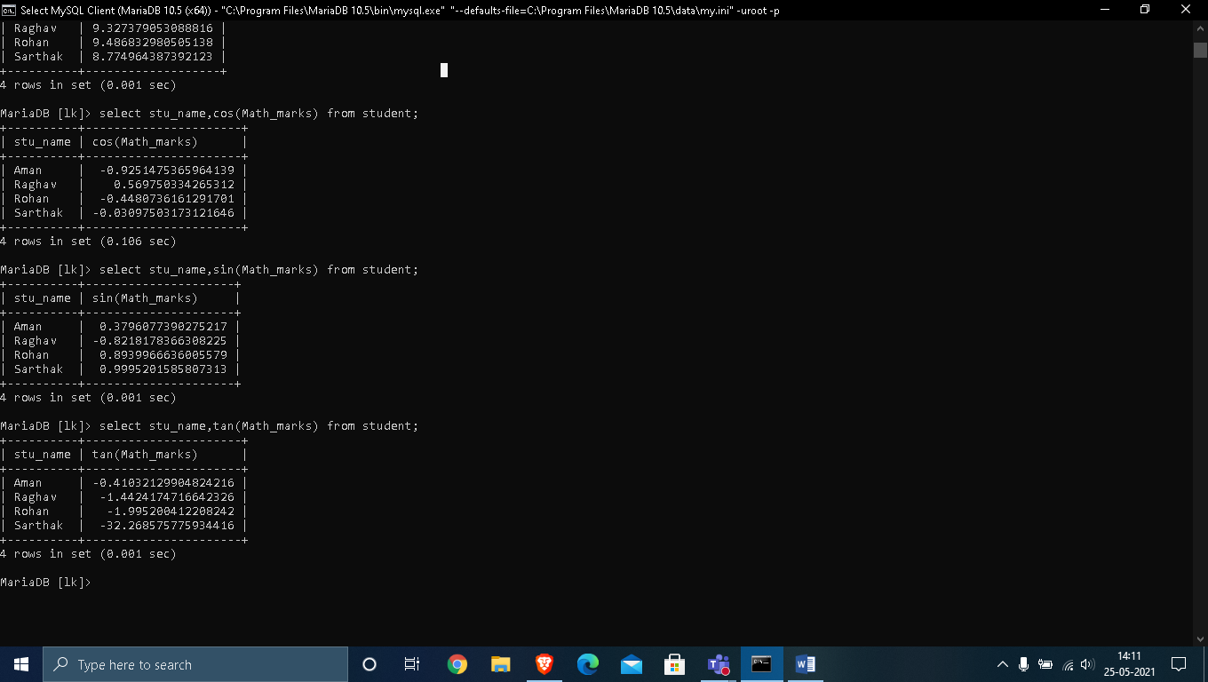

**3. ABS() , MOD() :**

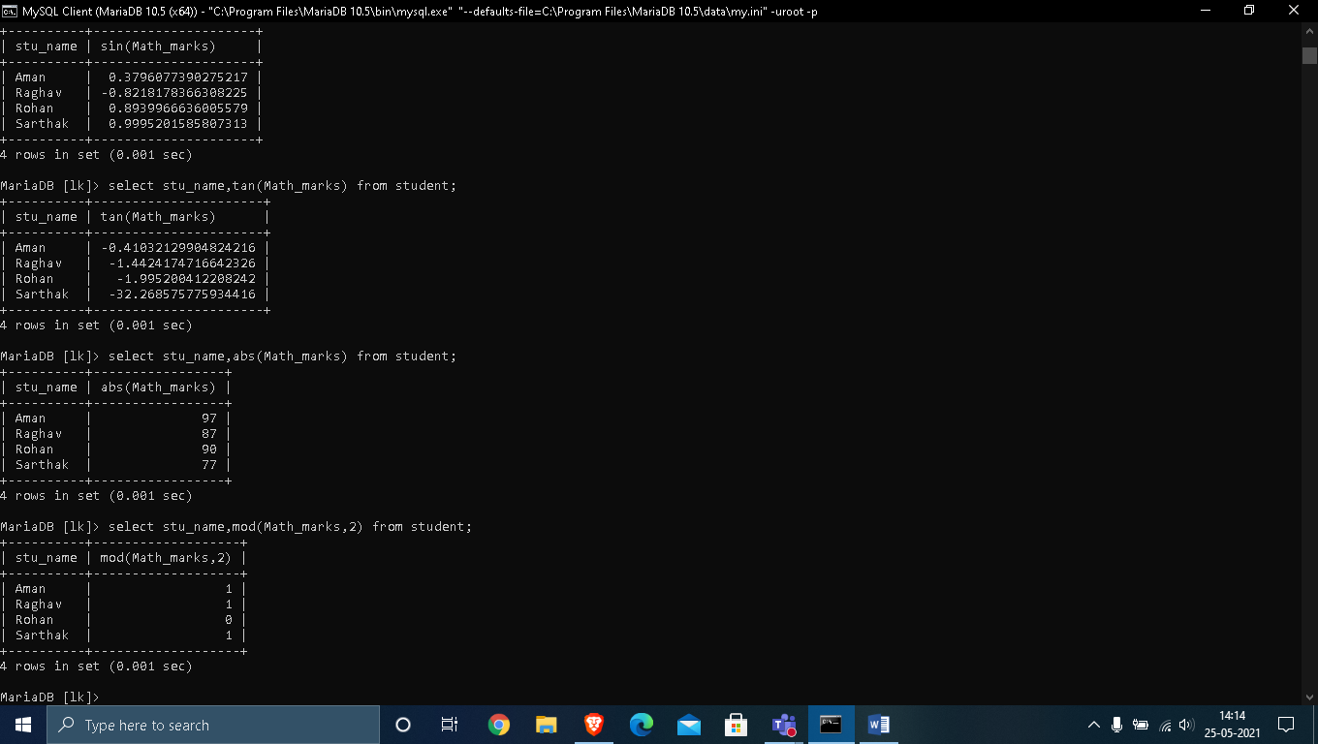

**4. MAX() , MIN() :**

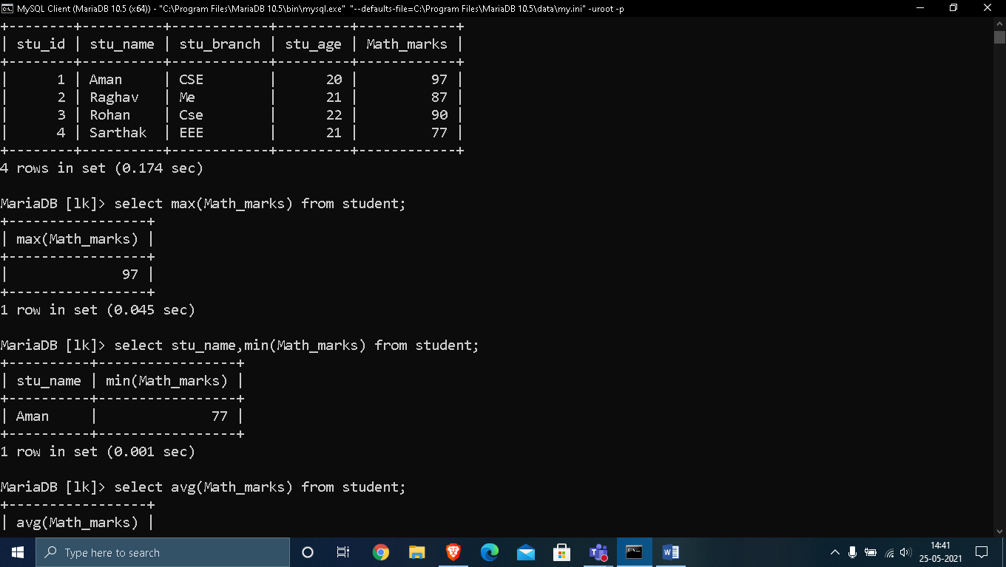

**5. AVG() , CEILING() :**

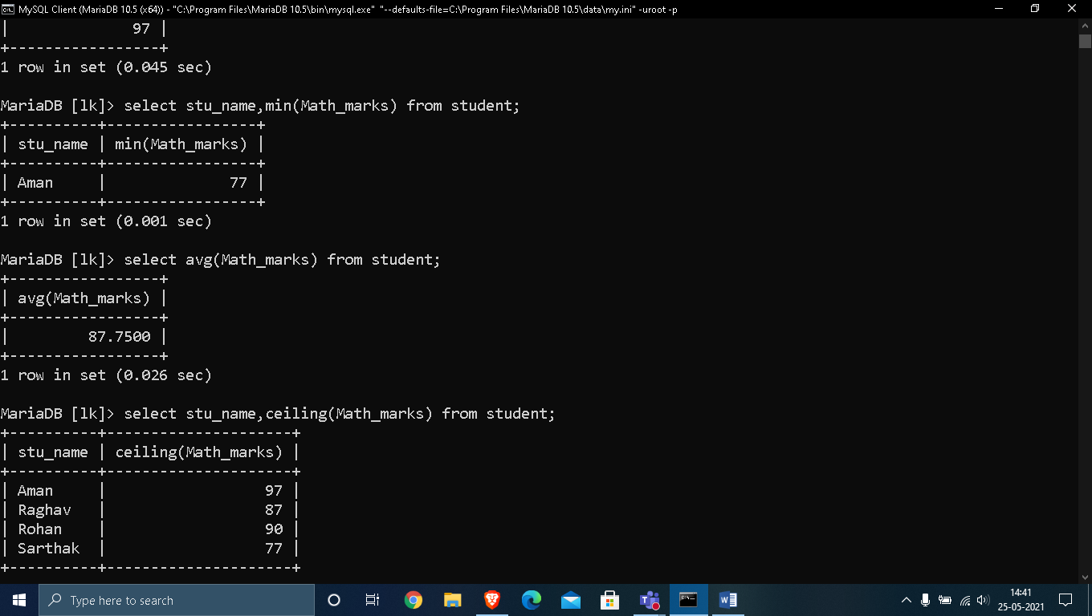

**# STRING FUNCTIONS :**

1. **ASCII():** This function is used to find the ASCII value of a character.

**Syntax:** SELECT ascii('t');

**Output:** 116

**2. CHAR_LENGTH():** Doesn’t work for SQL Server. Use LEN() for SQL Server. This function is used to find the length of a word.

**Syntax:** SELECT char_length('Hello!');

**Output:** 6

**3. CONCAT():** This function is used to add two words or strings.

**Syntax:** SELECT 'Geeks' || ' ' || 'forGeeks' FROM dual;

**Output:** ‘GeeksforGeeks’

**4. INSERT():** This function is used to insert the data into a database.

**Syntax:** INSERT INTO database (geek_id, geek_name) VALUES (5000, 'abc');

**Output:** successfully updated

**5. LCASE():** This function is used to convert the given string into lower case.

**Syntax:** LCASE ("GeeksFor Geeks To Learn");

**Output:** geeksforgeeks to learn

**6. LENGTH():** This function is used to find the length of a word.

**Syntax:** LENGTH('GeeksForGeeks');

**Output:** 13

**7. LOWER():** This function is used to convert the upper case string into lower case.

**Syntax:** SELECT LOWER('GEEKSFORGEEKS.ORG');

**Output:** geeksforgeeks.org

**8. LPAD():** This function is used to make the given string of the given size by adding the given symbol.

**Syntax:** LPAD('geeks', 8, '0');

**Output:**

000geeks

**9. LTRIM():** This function is used to cut the given sub string from the original string.

**Syntax:** LTRIM('123123geeks', '123');

**Output:** geeks

**10. REVERSE():** This function is used to reverse a string.

**Syntax:** SELECT REVERSE('geeksforgeeks.org');

**Output:** ‘gro.skeegrofskeeg’

**11. RPAD():** This function is used to make the given string as long as the given size by adding the given symbol on the right.

**Syntax:** RPAD('geeks', 8, '0');

**Output:** ‘geeks000’

**12.RTRIM():** This function is used to cut the given sub string from the original string.

**Syntax:** RTRIM('geeksxyxzyyy', 'xyz');

**Output:** ‘geeks’

**13. STRCMP():** This function is used to compare 2 strings.

* + If string1 and string2 are the same, the STRCMP function will return 0.
  + If string1 is smaller than string2, the STRCMP function will return -1.
  + If string1 is larger than string2, the STRCMP function will return 1.

**Syntax:** SELECT STRCMP('google.com', 'geeksforgeeks.com');

**Output:** -1

**14. SUBSTRING():** This function is used to find an alphabet from the mentioned size and the given string.

**Syntax:** SELECT SUBSTRING('GeeksForGeeks.org', 9, 1);

**Output:** ‘G’

**15.UCASE():** This function is used to make the string in upper case.

**Syntax:** UCASE ("GeeksForGeeks");

**Output:**

GEEKSFORGEEKS

**# OUTPUT :**

**1. ASCII() :**

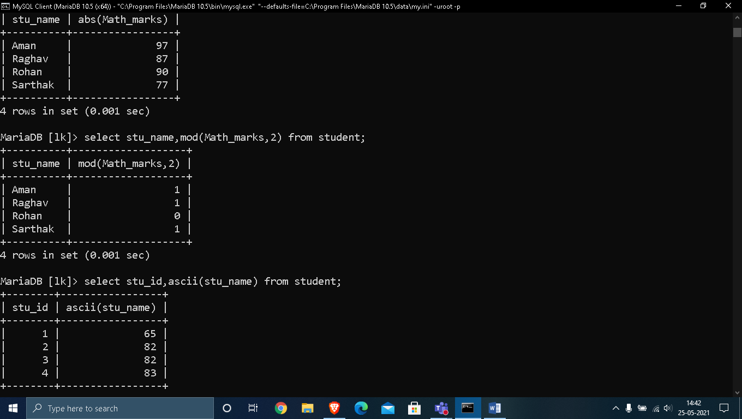

**2. CHAR_LENGTH () , CONCAT():**

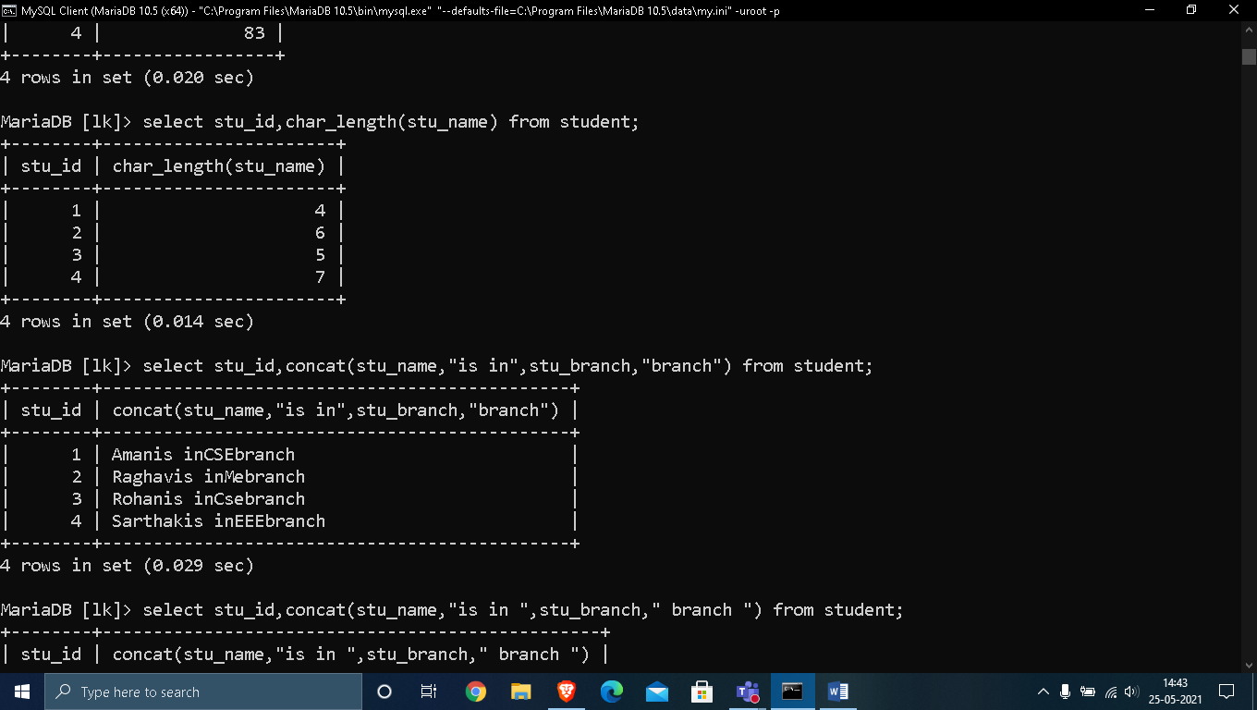

**3. Lcase():**

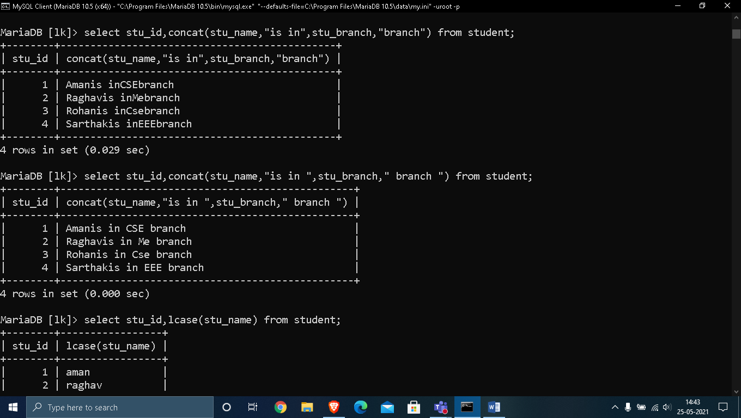

**4. LOWER() , UPPER() :**

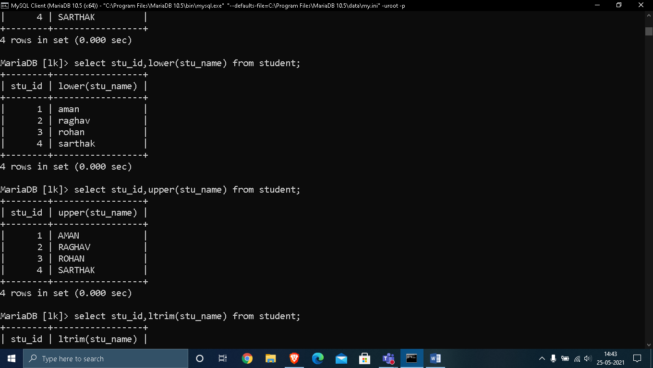

**5. LTRIM() , RTRIM() :**

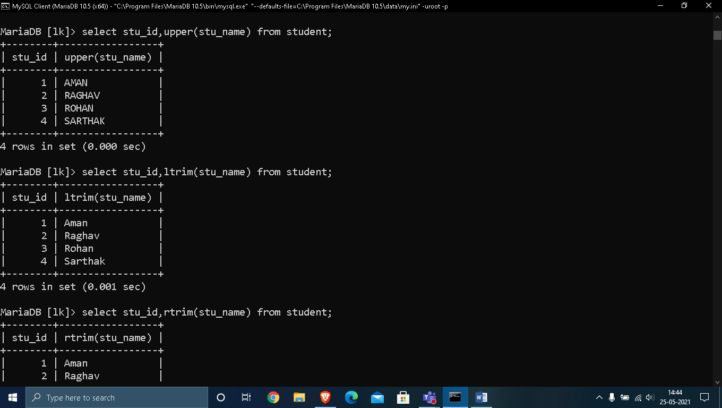

**6. LPAD() :**

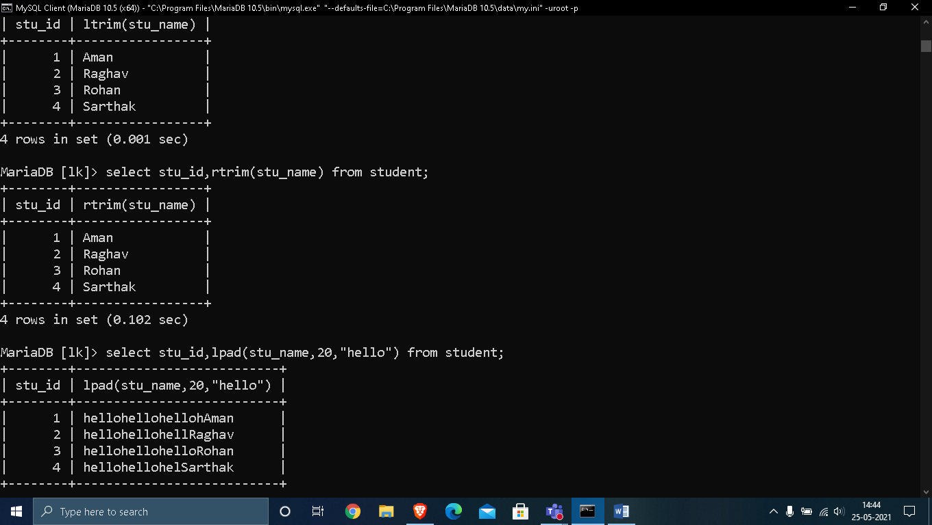

**7. RPAD() , REVERSE() :**

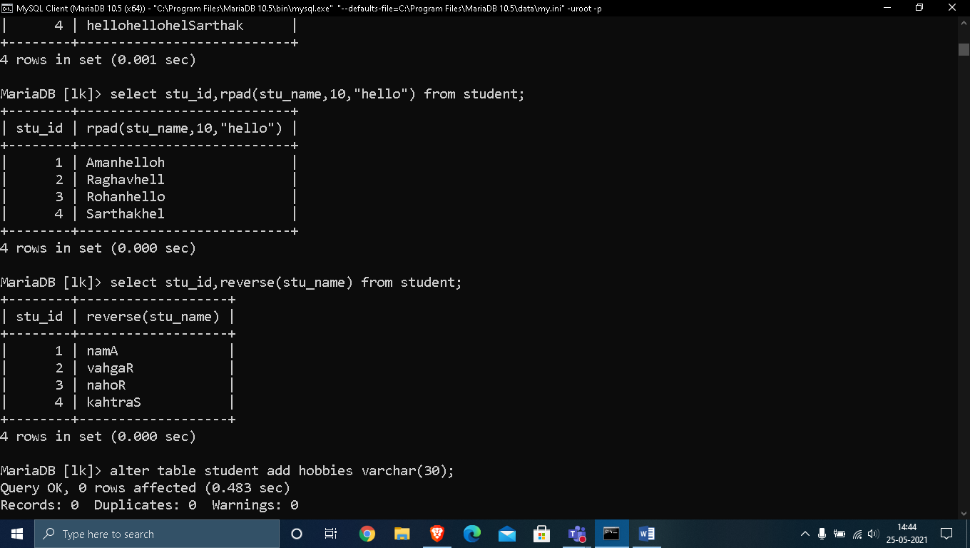

**8. STRCMP() :**

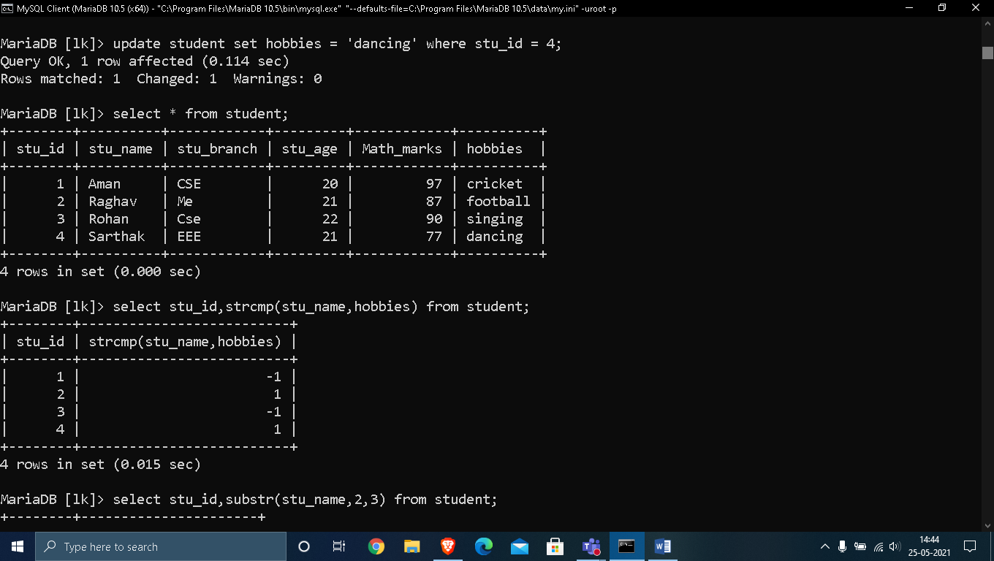

**9.SUBSTRING() , BIT_LENGTH() :**

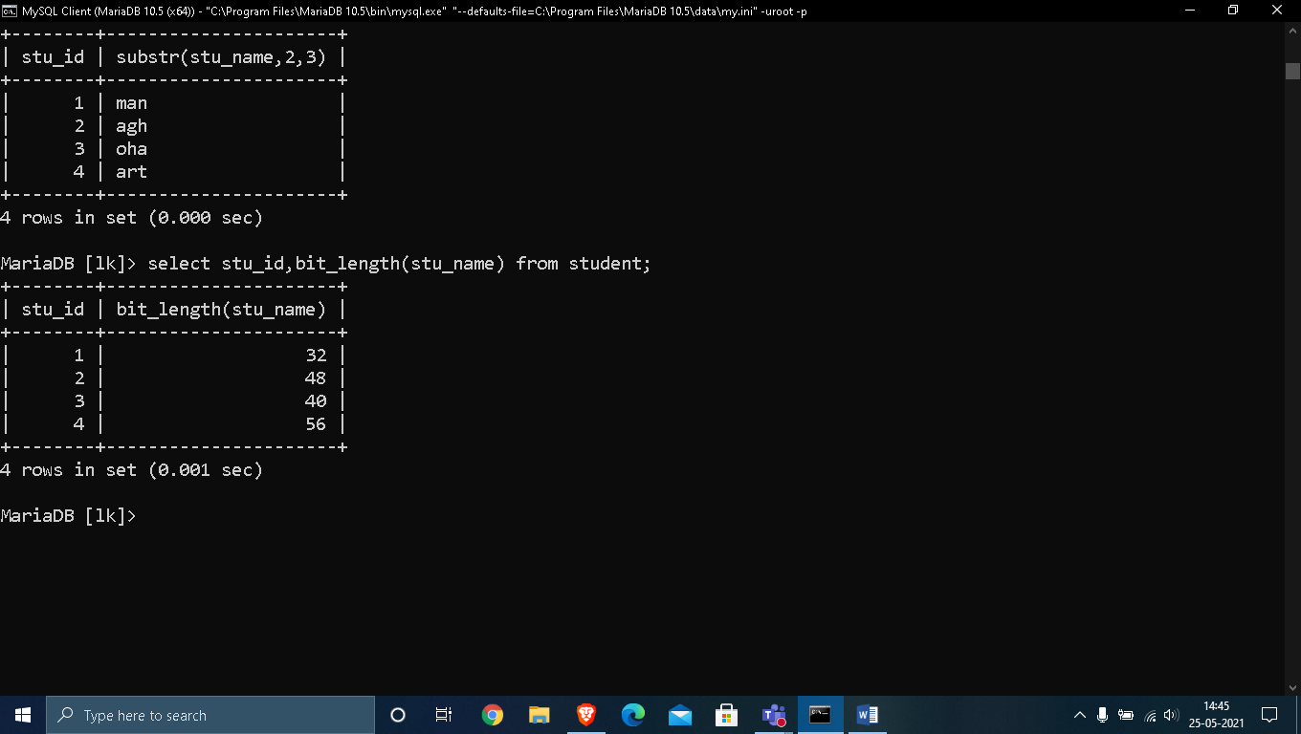

EXPERIMENT – 5

AIM : Implementation of Operators and Views on a given database.

THEORY : ( OPERATORS)

SQL Arithmetic Operators

Assume **'variable a'** holds 10 and **'variable b'** holds 20,

|  |  |  |
| --- | --- | --- |
| **Operator** | **Description** | **Example** |
| + (Addition) | Adds values on either side of the operator. | a + b will give 30 |
| - (Subtraction) | Subtracts right hand operand from left hand operand. | a - b will give -10 |
| * (Multiplication) | Multiplies values on either side of the operator. | a * b will give 200 |
| / (Division) | Divides left hand operand by right hand operand. | b / a will give 2 |
| % (Modulus) | Divides left hand operand by right hand operand and returns remainder. | b % a will give 0 |

## SQL Logical Operators

|  |  |
| --- | --- |
| **Sr.No.** | **Operator & Description** |
| 1 | **ALL**  The ALL operator is used to compare a value to all values in another value set. |
| 2 | **AND**  The AND operator allows the existence of multiple conditions in an SQL statement's WHERE clause. |
| 3 | **ANY**  The ANY operator is used to compare a value to any applicable value in the list as per the condition. |
| 4 | **BETWEEN**  The BETWEEN operator is used to search for values that are within a set of values, given the minimum value and the maximum value. |
| 5 | **EXISTS**  The EXISTS operator is used to search for the presence of a row in a specified table that meets a certain criterion. |
| 6 | **IN**  The IN operator is used to compare a value to a list of literal values that have been specified. |
| 7 | **LIKE**  The LIKE operator is used to compare a value to similar values using wildcard operators. |
| 8 | **NOT**  The NOT operator reverses the meaning of the logical operator with which it is used. Eg: NOT EXISTS, NOT BETWEEN, NOT IN, etc. **This is a negate operator.** |
| 9 | **OR**  The OR operator is used to combine multiple conditions in an SQL statement's WHERE clause. |

## SQL Comparison Operators

Assume **'variable a'** holds 10 and **'variable b'** holds 20, then −

|  |  |  |
| --- | --- | --- |
| **Operator** | **Description** | **Example** |
| = | Checks if the values of two operands are equal or not, if yes then condition becomes true. | (a = b) is not true. |
| != | Checks if the values of two operands are equal or not, if values are not equal then condition becomes true. | (a != b) is true. |
| <> | Checks if the values of two operands are equal or not, if values are not equal then condition becomes true. | (a <> b) is true. |
| > | Checks if the value of left operand is greater than the value of right operand, if yes then condition becomes true. | (a > b) is not true. |
| < | Checks if the value of left operand is less than the value of right operand, if yes then condition becomes true. | (a < b) is true. |
| >= | Checks if the value of left operand is greater than or equal to the value of right operand, if yes then condition becomes true. | (a >= b) is not true. |
| <= | Checks if the value of left operand is less than or equal to the value of right operand, if yes then condition becomes true. | (a <= b) is true. |

OUTPUT :

1. Arithmetic Operators:

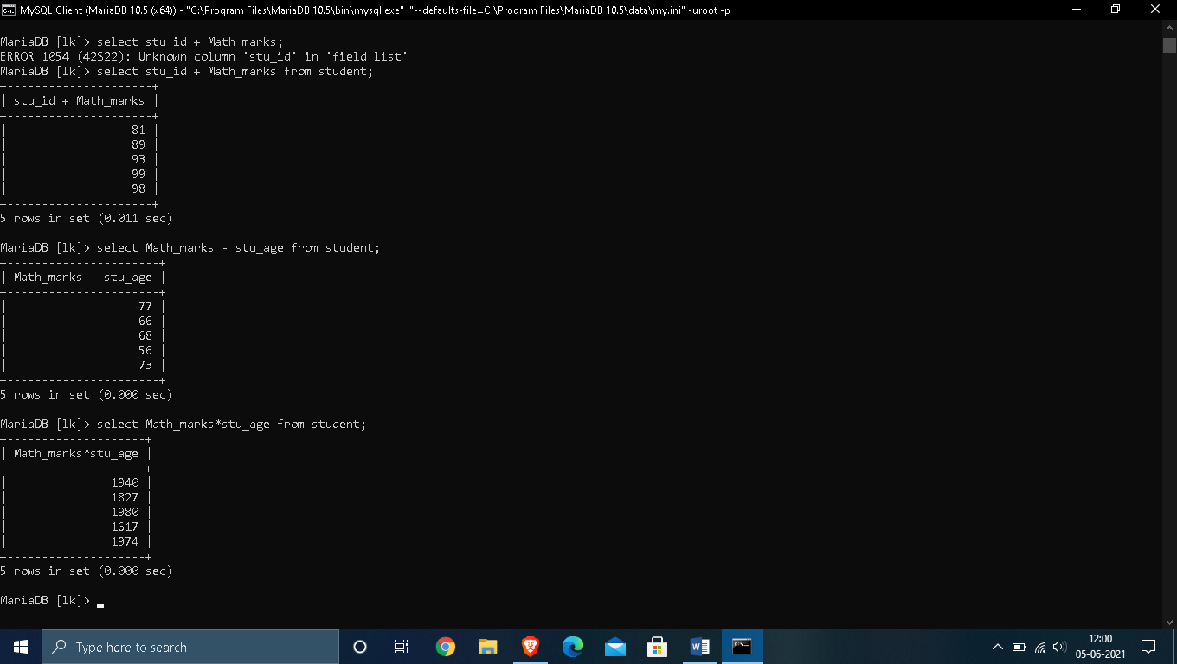

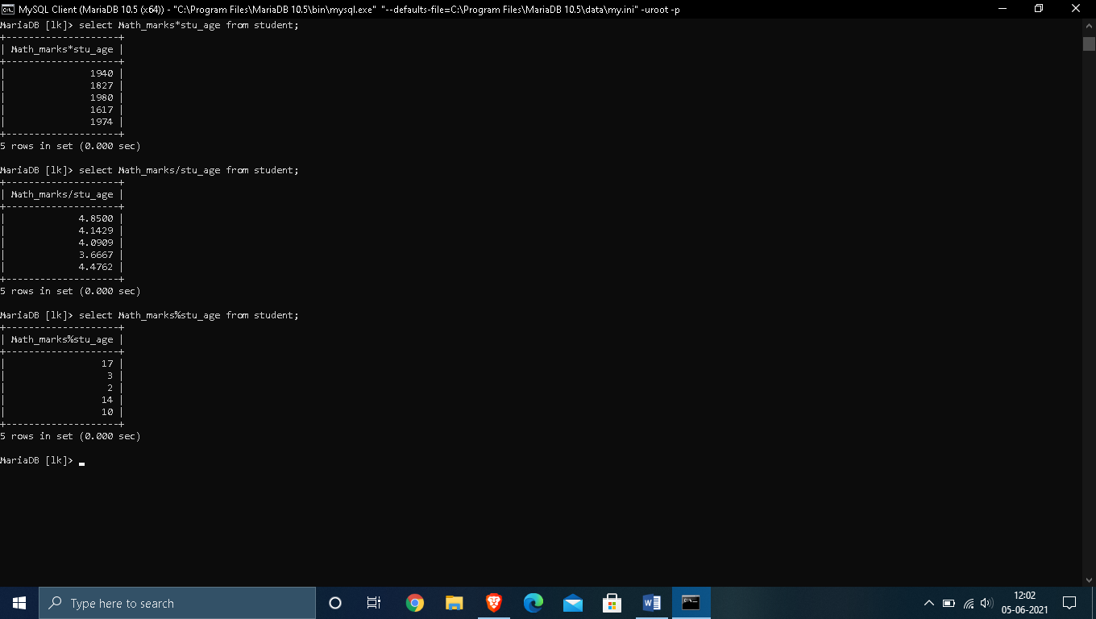

2. Logical Operators :

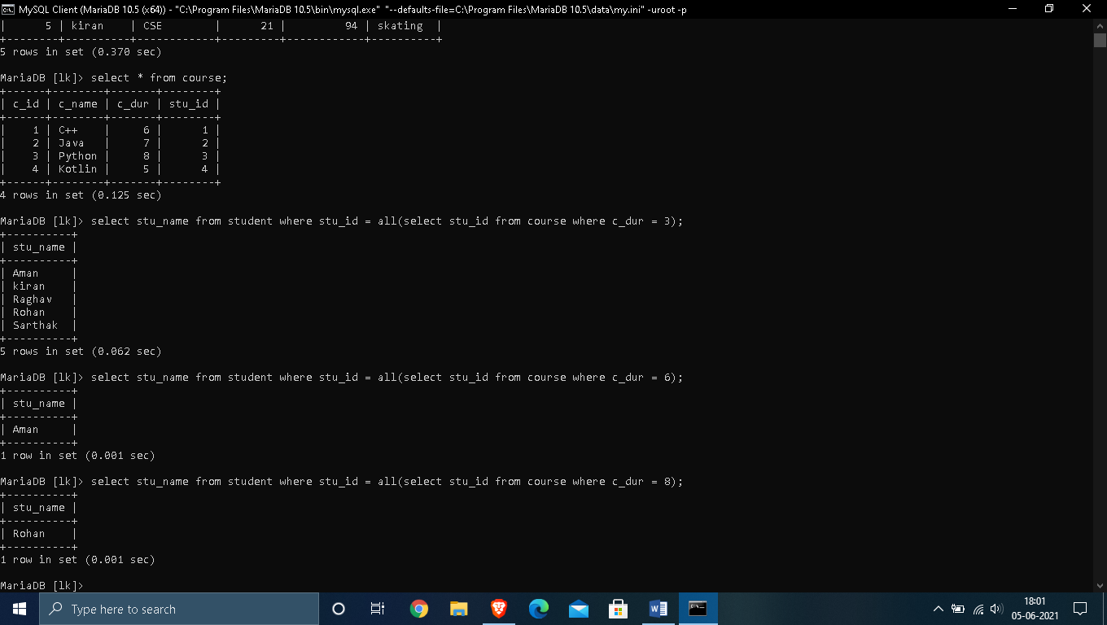

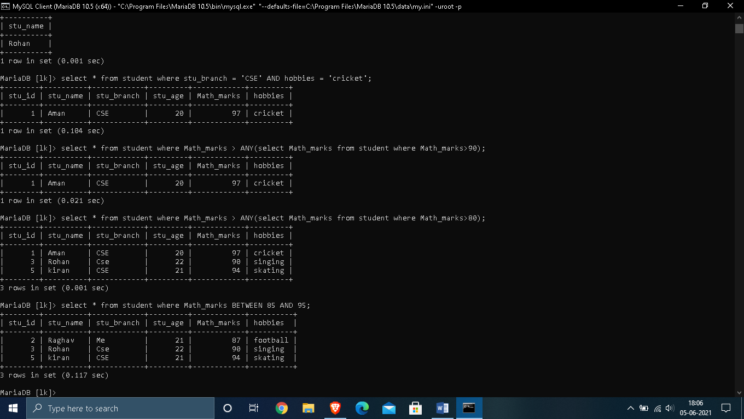

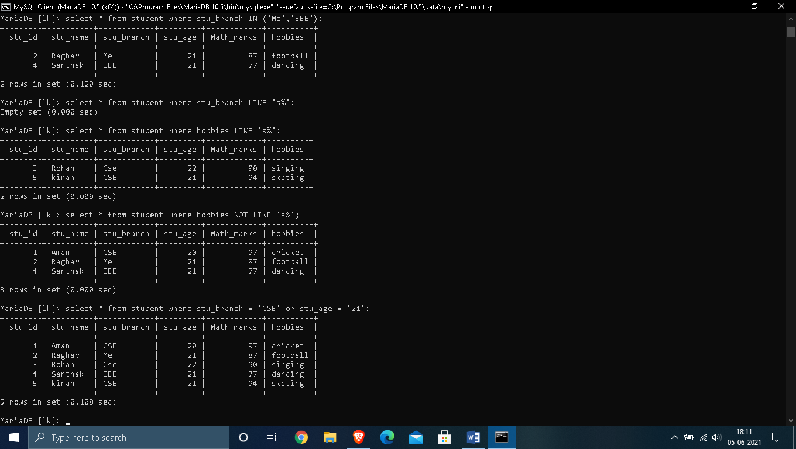

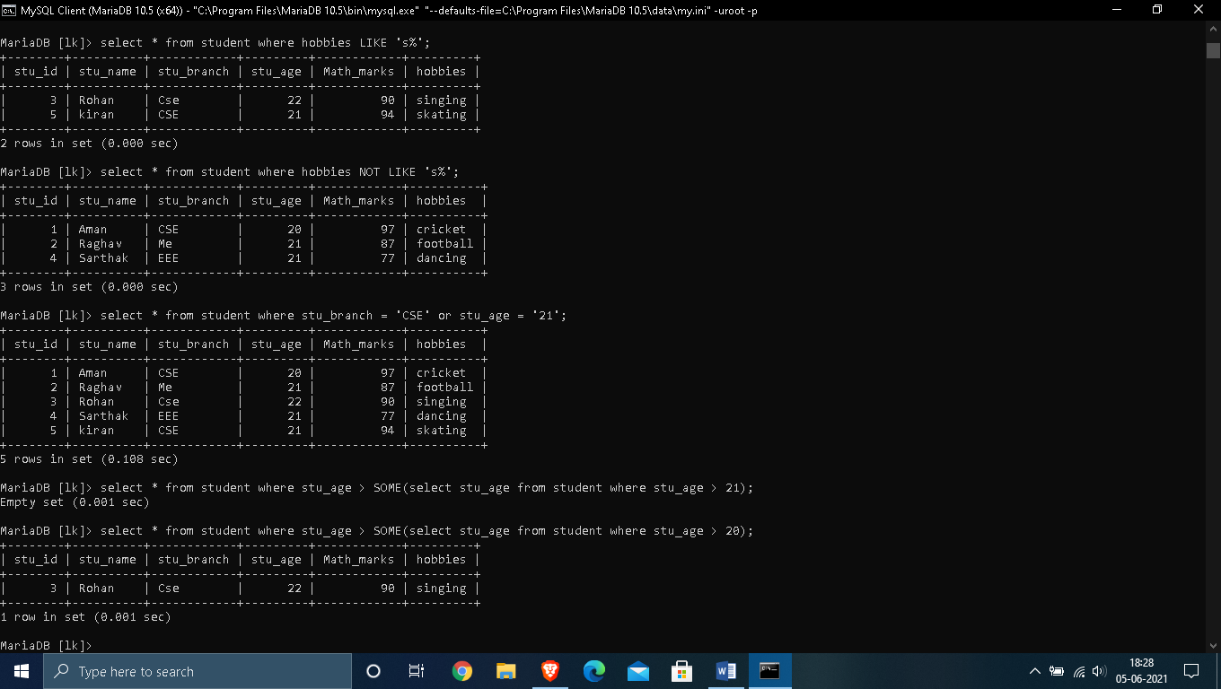

3. Comparison Operators :

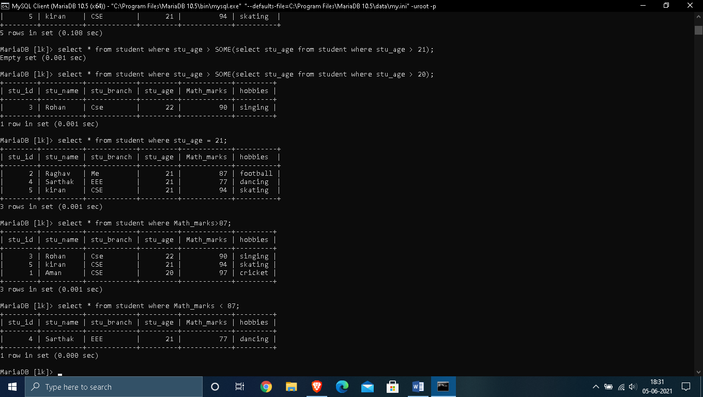

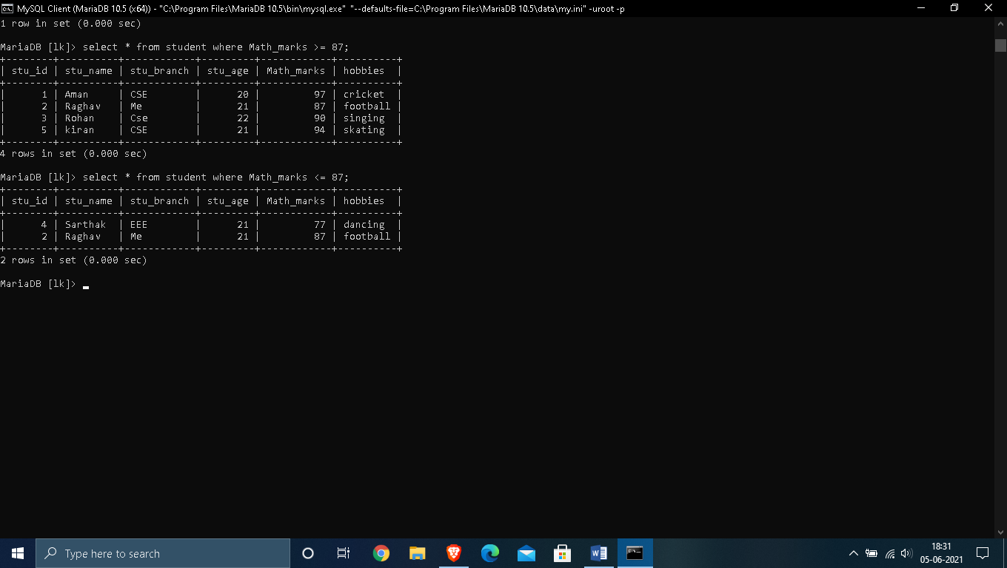

VIEWS

* Views in SQL are considered as a virtual table. A view also contains rows and columns.
* To create the view, we can select the fields from one or more tables present in the database.
* A view can either have specific rows based on certain condition or all the rows of a table.

1. Creating view

A view can be created using the **CREATE VIEW** statement. We can create a view from a single table or multiple tables.

**Syntax:**

CREATE VIEW view_name AS

SELECT column1, column2.....

FROM table_name

WHERE condition;

2. Creating View from a single table

In this example, we create a View named DetailsView from the table Student_Detail.

**Query:**

CREATE VIEW DetailsView AS

SELECT NAME, ADDRESS

FROM Student_Details

WHERE STU_ID < 4;

Just like table query, we can query the view to view the data.

SELECT * FROM DetailsView;

3. Creating View from multiple tables

View from multiple tables can be created by simply include multiple tables in the SELECT statement.

In the given example, a view is created named MarksView from two tables Student_Detail and Student_Marks.

**Query:**

CREATE VIEW MarksView AS

SELECT Student_Detail.NAME, Student_Detail.ADDRESS, Student_Marks.MARKS

FROM Student_Detail, Student_Mark

WHERE Student_Detail.NAME = Student_Marks.NAME;

To display data of View MarksView:

SELECT * FROM MarksView;

4. Deleting View

A view can be deleted using the Drop View statement.

**Syntax**

DROP VIEW view_name;

**Example:**

If we want to delete the View **MarksView**, we can do this as:

DROP VIEW MarksView;

* OUTPUT :

1. Creating a view :

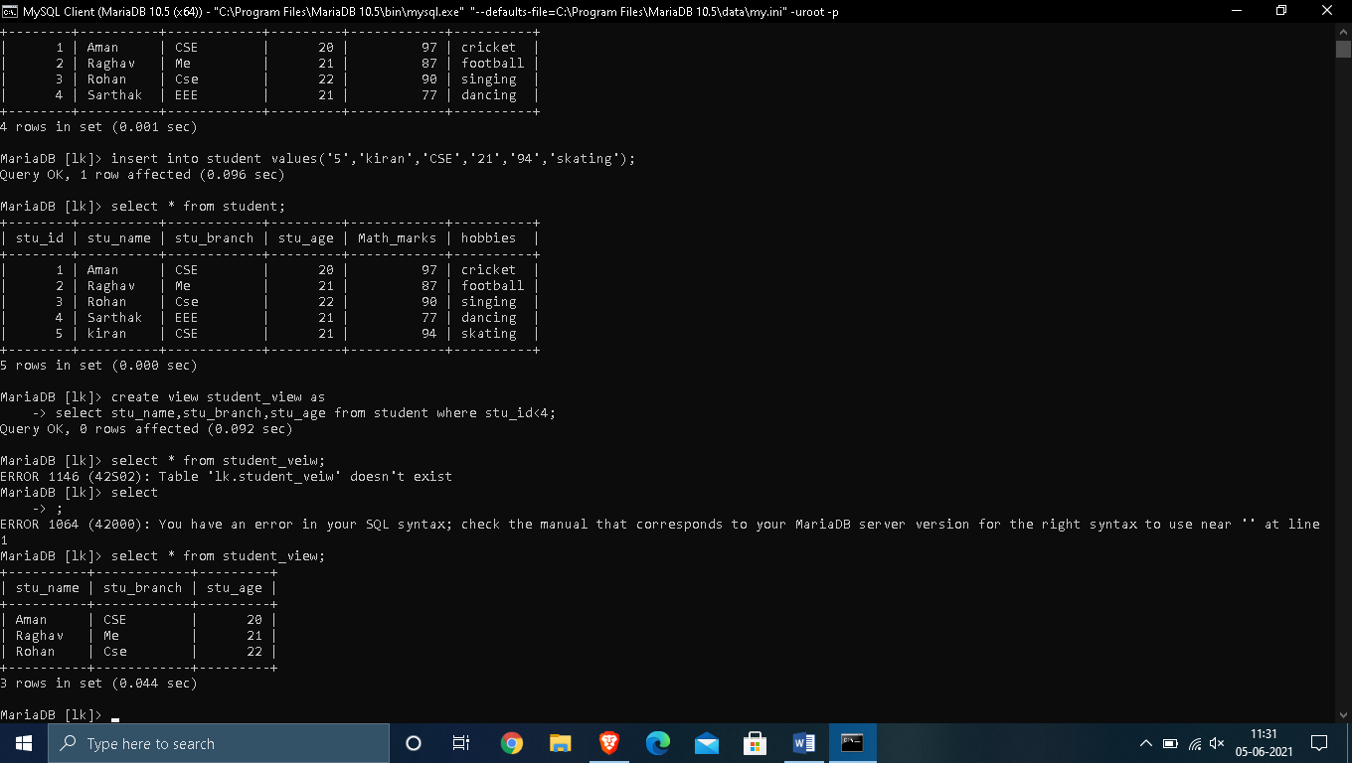



## 2. . Creating View from multiple tables

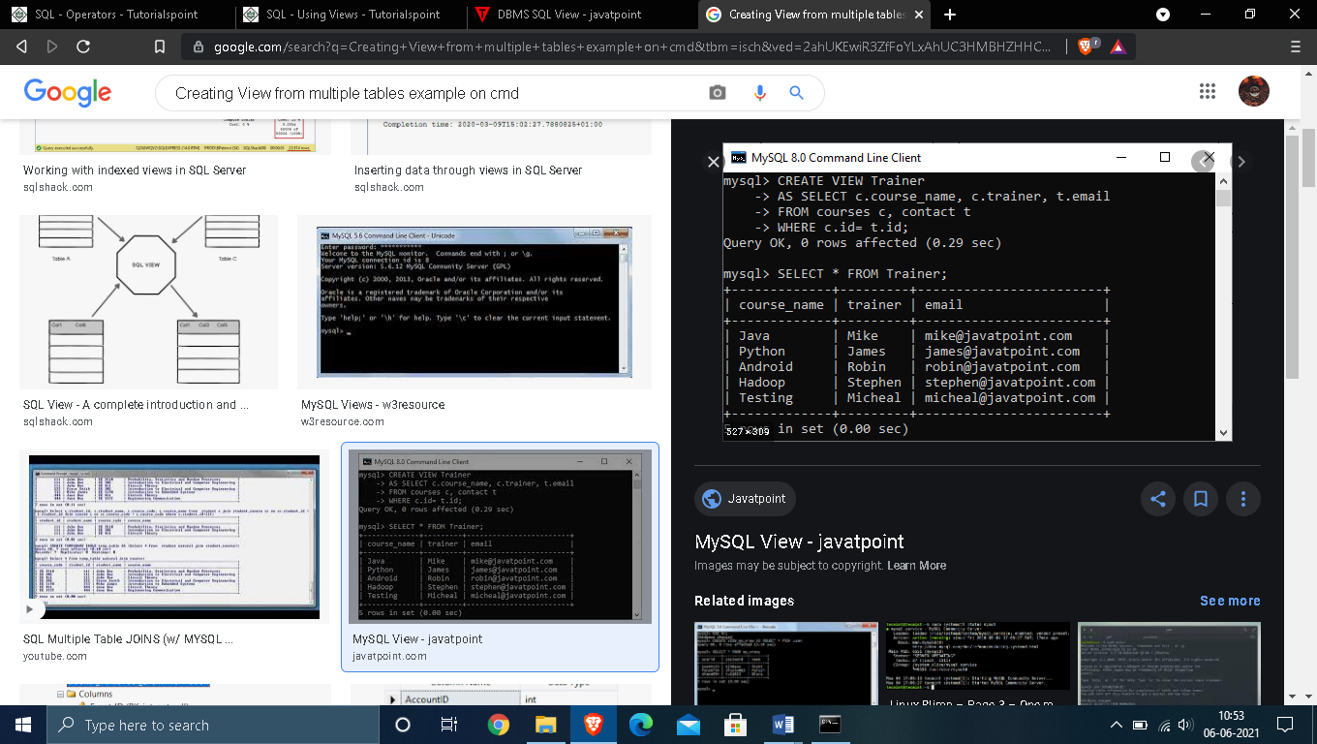

## 3.  Deleting View

## 

**EXPERIMENT – 6**

**AIM : Implementation of Joins and Index on a given Database.**

**THEORY :**

SQL JOIN

As the name shows, JOIN means to combine something. In case of SQL, JOIN means "to combine two or more tables".

In SQL, JOIN clause is used to combine the records from two or more tables in a database.

Types of SQL JOIN

1. INNER JOIN
2. LEFT JOIN
3. RIGHT JOIN
4. FULL JOIN

### **1. INNER JOIN**

In SQL, INNER JOIN selects records that have matching values in both tables as long as the condition is satisfied. It returns the combination of all rows from both the tables where the condition satisfies.

**Syntax**

1. SELECT table1.column1, table1.column2, table2.column1,....
2. FROM table1
3. INNER JOIN table2
4. ON table1.matching_column = table2.matching_column;

### **2. LEFT JOIN**

The SQL left join returns all the values from left table and the matching values from the right table. If there is no matching join value, it will return NULL.

**Syntax**

1. SELECT table1.column1, table1.column2, table2.column1,....
2. FROM table1
3. LEFT JOIN table2
4. ON table1.matching_column = table2.matching_column;

### **3. RIGHT JOIN**

In SQL, RIGHT JOIN returns all the values from the values from the rows of right table and the matched values from the left table. If there is no matching in both tables, it will return NULL.

**Syntax**

1. SELECT table1.column1, table1.column2, table2.column1,....
2. FROM table1
3. RIGHT JOIN table2
4. ON table1.matching_column = table2.matching_column;

### **4. FULL JOIN**

In SQL, FULL JOIN is the result of a combination of both left and right outer join. Join tables have all the records from both tables. It puts NULL on the place of matches not found.

**Syntax**

1. SELECT table1.column1, table1.column2, table2.column1,....
2. FROM table1
3. FULL JOIN table2
4. ON table1.matching_column = table2.matching_column;

**OUTPUT :**

**1. INNER JOIN & LEFT JOIN :**

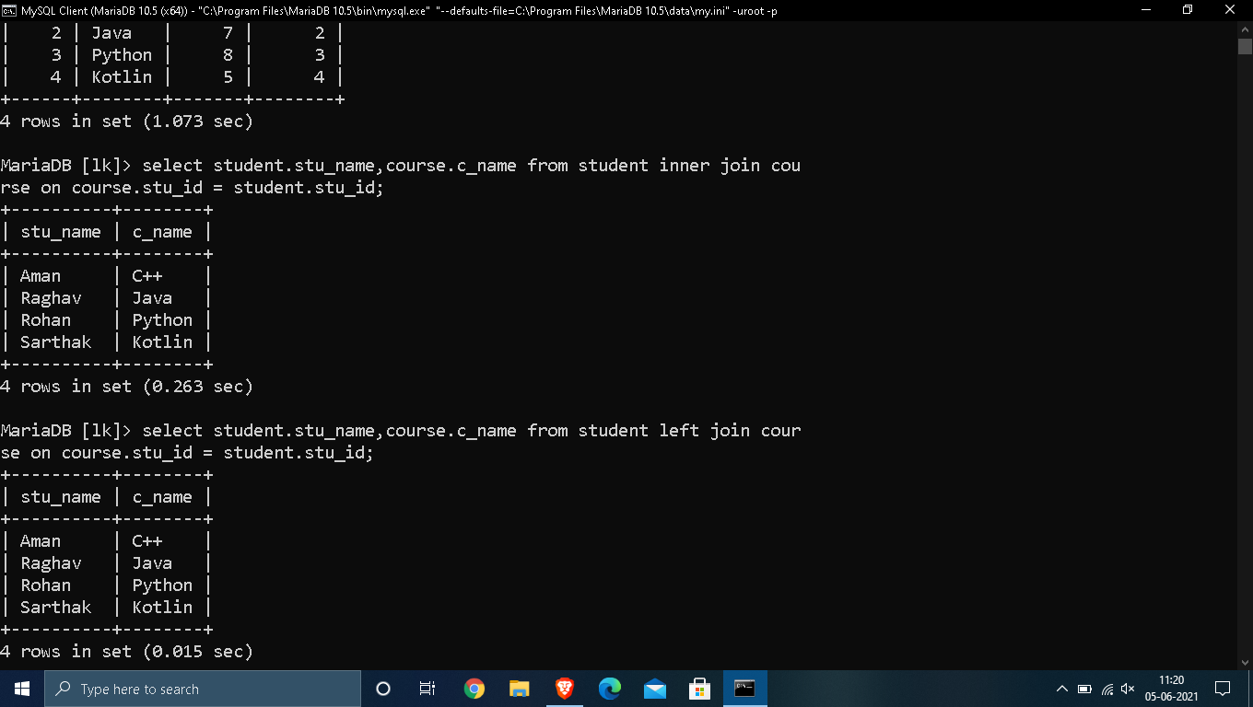

**2. RIGHT JOIN:**

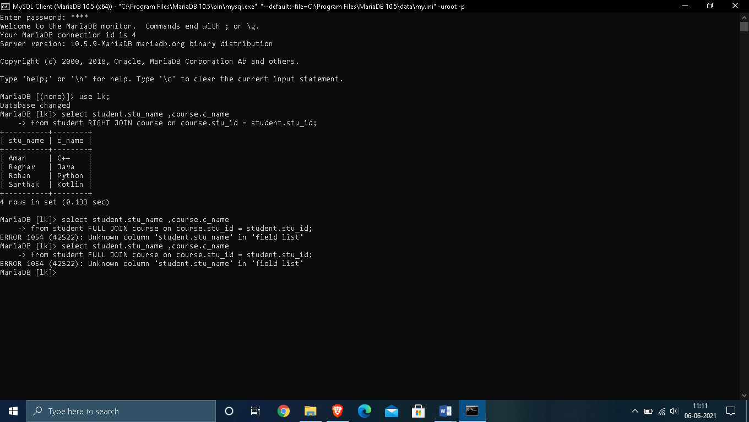

**3. FULL JOIN :**

SQL Index

* Indexes are special lookup tables. It is used to retrieve data from the database very fast.
* An Index is used to speed up select queries and where clauses. But it shows down the data input with insert and update statements. Indexes can be created or dropped without affecting the data.
* An index in a database is just like an index in the back of a book.
* **For example:** When you reference all pages in a book that discusses a certain topic, you first have to refer to the index, which alphabetically lists all the topics and then referred to one or more specific page numbers.

1. Create Index statement

It is used to create an index on a table. It allows duplicate value.

**Syntax**

CREATE INDEX index_name

ON table_name (column1, column2, ...);

2. Unique Index statement

It is used to create a unique index on a table. It does not allow duplicate value.

**Syntax**

CREATE UNIQUE INDEX index_name

ON table_name (column1, column2, ...);

3. Drop Index Statement

It is used to delete an index in a table.

**Syntax**

DROP INDEX index_name;

**OUTPUT :**

**1. Create Index :**

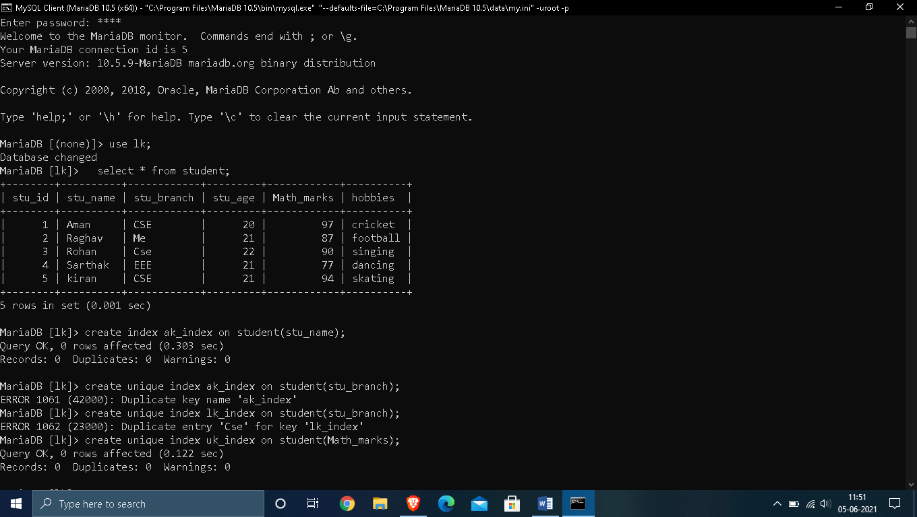

**2. Create Unique Index & Drop Index :**

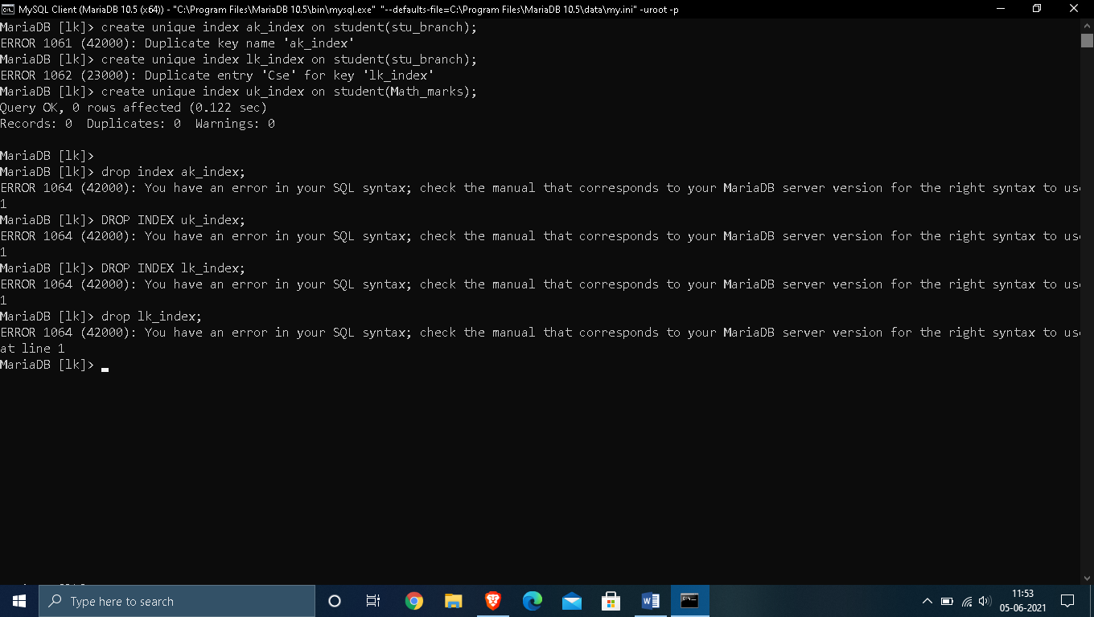

EXPERIMENT 7

**Aim**: To study the PL/SQL Database Management language

**Theory**:

**PL/SQL** is a combination of SQL along with the procedural features of programming languages. It was developed by Oracle Corporation in the early 90's to enhance the capabilities of SQL. PL/SQL is one of three key programming languages embedded in the Oracle Database, along with SQL itself and Java.

**Features of PL/SQL**

* completely portable, high-performance transaction-processing language
* provides a built-in, interpreted and OS independent programming environment
* direct call can also be made from external programming language calls to database
* available in TimesTen in-memory database and IBM DB2

**Advantages of PL/SQL**

* PL/SQL provides high security level
* PL/SQL provides access to predefined SQL packages
* PL/SQL provides support for Object-Oriented Programming
* PL/SQL provides support for developing Web Applications and Server Pages.

**PL/SQL Identifiers**

PL/SQL identifiers are constants, variables, exceptions, procedures, cursors, and reserved words. The identifiers consist of a letter optionally followed by more letters, numerals, dollar signs, underscores, and number signs and should not exceed 30 characters.

By default, identifiers are not case-sensitive.

**PL/SQL Delimiters**

A delimiter is a symbol with a special meaning. Following is the list of delimiters in PL/SQL −

|  |  |
| --- | --- |
| +, -, *, / | Addition, subtraction/negation, multiplication, division |
| % | Attribute indicator |
| ' | Character string delimiter |
| . | Component selector |
| (,) | Expression or list delimiter |
| : | Host variable indicator |
| , | Item separator |
| " | Quoted identifier delimiter |
| = | Relational operator |
| @ | Remote access indicator |
| ; | Statement terminator |
| := | Assignment operator |
| => | Association operator |
| || | Concatenation operator |
| ** | Exponentiation operator |
| <<, >> | Label delimiter (begin and end) |
| /*, */ | Multi-line comment delimiter (begin and end) |
| -- | Single-line comment indicator |
| .. | Range operator |
| <, >, <=, >= | Relational operators |
| <>, '=, ~=, ^= | Different versions of NOT EQUAL |

**PL/SQL SCALAR DATA TYPES**

PL/SQL Scalar Data Types and Subtypes come under the following categories −

|  |  |
| --- | --- |
| **S.No** | **Date Type & Description** |
| 1 | Numeric  Numeric values on which arithmetic operations are performed. |
| 2 | Character  Alphanumeric values that represent single characters or strings of characters. |
| 3 | Boolean  Logical values on which logical operations are performed. |
| 4 | Datetime  Dates and times. |

**PL/SQL Code**

**DECLARE**

**num1 INTEGER;**

**num2 REAL;**

**num3 DOUBLE PRECISION;**

**BEGIN**

**null;**

**END;**

**/**

**Output**

**PL/SQL procedure successfully completed**

EXPERIMENT 8

**Aim**: To study the different types of cursors and its implementation

**Theory**:

**Cursor** is a Temporary Memory or Temporary Work Station. It is Allocated by Database Server at the Time of Performing DML operations on Table by User. Cursors are used to store Database Tables. There are 2 types of Cursors: Implicit Cursors, and Explicit Cursors.

**Implicit Cursors:** Implicit Cursors are also known as Default Cursors of SQL SERVER. These Cursors are allocated by SQL SERVER when the user performs DML operations.

**Explicit Cursors:** Explicit Cursors are Created by Users whenever the user requires them. Explicit Cursors are used for Fetching data from Table in Row-By-Row Manner.

**Implicit Cursors Attributes**

|  |  |
| --- | --- |
| **S.No** | **Attribute & Description** |
| 1 | %FOUND  Returns TRUE if an INSERT, UPDATE, or DELETE statement affected one or more rows or a SELECT INTO statement returned one or more rows. Otherwise, it returns FALSE. |
| 2 | %NOTFOUND  The logical opposite of %FOUND. It returns TRUE if an INSERT, UPDATE, or DELETE statement affected no rows, or a SELECT INTO statement returned no rows. Otherwise, it returns FALSE. |
| 3 | %ISOPEN  Always returns FALSE for implicit cursors, because Oracle closes the SQL cursor automatically after executing its associated SQL statement. |
| 4 | %ROWCOUNT  Returns the number of rows affected by an INSERT, UPDATE, or DELETE statement, or returned by a SELECT INTO statement. |

**Creating Explicit Cursors**

1. **Creating cursor object**

Syntax: DECLARE cursor_name CURSOR FOR SELECT * FROM table_name;

1. **Open Cursor Connection**

Syntax: OPEN cursor_connection;

1. **Fetching Data from Cursors**

There are a total of 6 methods to access data from the cursor. They are as follows:

**FIRST** is used to fetch only the first row from the cursor table.

**LAST** is used to fetch only the last row from the cursor table.

**NEXT** is used to fetch data in forward direction from the cursor table.

**PRIOR** is used to fetch data in backward direction from the cursor table.

**ABSOLUTE** n is used to fetch the exact nth row from the cursor table.

**RELATIVE** n is used to fetch the data in incremental as well as decremental ways.

Syntax: FETCH NEXT/FIRST/LAST/PRIOR/ABSOLUTE n/RELATIVE n FROM cursor_name

1. **Close Cursor Connection**

**Syntax**: CLOSE cursor_name

1. **Deallocate cursor memory.**

**Syntax**:DEALLOCATE cursor_name

**Code**

**DECLARE**

**total_rows number(2);**

**BEGIN**

**UPDATE customers**

**SET salary = salary + 500;**

**IF sql%notfound THEN**

**dbms_output.put_line('no customers selected');**

**ELSIF sql%found THEN**

**total_rows := sql%rowcount;**

**dbms_output.put_line( total_rows || ' customers selected ');**

**END IF;**

**END;**

**/**

**OUTPUT**

**6 customers selected**

**PL/SQL procedure successfully completed.**

**EXPERIMENT 9**

**AIM**: To study the different types of triggers and its implementation.

**THEORY**:

A “trigger” is defined as any event that sets a course of action in a motion.

In PostgreSQL, if you want to take action on specific database events, such as INSERT, UPDATE, DELETE, or TRUNCATE, then trigger functionality can be useful as it will invoke the required function on defined events.

The trigger will be associated with the specified table, view, or foreign table and will execute the specified function when certain operations are performed on that table. Depending on the requirement we can create trigger BEFORE, AFTER or INSTEAD of the events/operation.

# *Types of Triggers –*

1. Row Level Trigger: If the trigger is marked **FOR EACH ROW** then the trigger function will be called for each row that is getting modified by the event.

For example: If we UPDATE 100 rows in the table, the UPDATE trigger function will be called 100 times, once for each updated row.

1. Statement Level Trigger: The **FOR EACH**

**STATEMENT** optionwill call the trigger function only once for each statement, regardless of the number of the rows getting modified.

# *Creating a Trigger –*

The SQL command CREATE TRIGGER creates a trigger on the specified object.

The syntax of the CREATE TRIGGER is as follows:

|  |
| --- |
| CREATE [ CONSTRAINT ] TRIGGER name { BEFORE | AFTER | INSTEAD  OF } { event [ OR ... ] }  ON table_name  [ FROM referenced_table_name ]  [ NOT DEFERRABLE | [ DEFERRABLE ] { INITIALLY IMMEDIATE |  INITIALLY DEFERRED } ]  [ FOR [ EACH ] { ROW | STATEMENT } ]  [ WHEN ( condition ) ]  EXECUTE PROCEDURE function_name ( arguments ) |

**CODE AND OUTPUT –**

CREATE TABLE employees( id INT GENERATED ALWAYS AS IDENTITY, first_name VARCHAR(40) NOT NULL, last_name VARCHAR(40) NOT NULL,

PRIMARY KEY(id)

);

CREATE TABLE employee_audits ( id INT GENERATED ALWAYS AS IDENTITY,

employee_id INT NOT NULL, last_name VARCHAR(40) NOT NULL,

changed_on TIMESTAMP(6) NOT NULL

);

CREATE OR REPLACE FUNCTION log_last_name_changes()

RETURNS TRIGGER

LANGUAGE PLPGSQL

AS

$$

BEGIN

IF NEW.last_name <> OLD.last_name THEN

INSERT INTO

employee_audits(employee_id,last_name,changed_on)

VALUES(OLD.id,OLD.last_name,now());

# END IF;

|  |  |  |
| --- | --- | --- |
| RETURN NEW; | | |
| END; | |  |
| $$ |  |

CREATE TRIGGER last_name_changes

BEFORE UPDATE

ON employees

FOR EACH ROW

EXECUTE PROCEDURE log_last_name_changes();

|  |  |
| --- | --- |
| INSERT INTO employees (first_name, last_name) | |
| VALUES ('John', 'Doe'); |  |

# SELECT * FROM employees;

UPDATE

employee

s

SET

last_name

=

'Brown

'

WHERE

ID

=

2

;

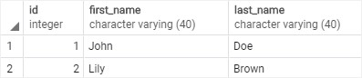

# SELECT * FROM employees;

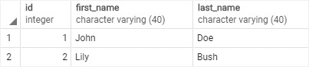

# SELECT * FROM employee_audits;

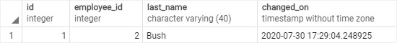

EXPERIMENT – 10

AIM :- Create a program in Pl-Sql.

THEORY:- PL/SQL is a combination of SQL along with the procedural features of programming languages. It was developed by Oracle Corporation in the early 90's to enhance the capabilities of SQL. PL/SQL is one of three key programming languages embedded in the Oracle Database, along with SQL itself and Java. This tutorial will give you great understanding on PL/SQL to proceed with Oracle database and other advanced RDBMS concepts.

**Overview of Pl- Sql:-**

PL/SQL is a block structured language that enables developers to combine the power of SQL with procedural statements.All the statements of a block are passed to oracle engine all at once which increases processing speed and decreases the traffic.

**Disadvantages of SQL:**

* SQL doesn’t provide the programmers with a technique of condition checking, looping and branching.
* SQL statements are passed to Oracle engine one at a time which increases traffic and decreases speed.
* SQL has no facility of error checking during manipulation of data.

**Features of PL/SQL:**

1. PL/SQL is basically a procedural language, which provides the functionality of decision making, iteration and many more features of procedural programming languages.
2. PL/SQL can execute a number of queries in one block using single command.
3. One can create a PL/SQL unit such as procedures, functions, packages, triggers, and types, which are stored in the database for reuse by applications.
4. PL/SQL provides a feature to handle the exception which occurs in PL/SQL block known as exception handling block.
5. Applications written in PL/SQL are portable to computer hardware or operating system where Oracle is operational.
6. PL/SQL Offers extensive error checking.

Advantages of Pl-Sql :-

 PL/SQL offers the following advantages over any other procedural language:

* support for SQL,
* closer integration with Oracle leading to better performance, and
* support for object-oriented programming.

**Program Code:-**

DECLARE

z_empid employees.employee_id%TYPE;

z_empname employees.first_name%TYPE;

z_salary employees.salary%TYPE;

CURSOR employee_cursor IS -- declaring a cursor

SELECT employee_id,

first_name,

salary

FROM employees;

BEGIN

OPEN employee_cursor; -- opening the cursor

LOOP

FETCH employee_cursor -- fetching records from the cursor

INTO z_empid,

z_empname,

z_salary;

EXIT

WHEN employee_cursor%NOTFOUND;

IF (z_salary > 8000) THEN

dbms_output.Put_line(z_empid

|| ' '

|| z_empname

|| ' '

|| z_salary);

ELSE

dbms_output.Put_line(z_empname

|| ' salary is less then 8000');

END IF;

END LOOP;

CLOSE employee_cursor; --closing the cursor

END;

/

OUTPUT :

SQL> /

100 Steven 24000

101 Neena 17000

102 Lex 17000

103 Alexander 9000

Bruce salary is less then 8000

David salary is less then 8000

Valli salary is less then 8000

Diana salary is less then 8000

108 Nancy 12008

109 Daniel 9000

110 John 8200

Ismael salary is less then 8000

Jose Manuel salary is less then 8000

Luis salary is less then 8000

114 Den 11000

...